

**NEW ERA UNIVERSITY COLLEGE**

**DEPARTMENT OF COMPUTER SCIENCE & INFORMATION TECHNOLOGY**

**BACHELOR OF SOFTWARE ENGINEERING**

**BIBWB2214 - Web Application Development**

**CANDACE LEE XIAO XUEN 1930165 - BSE**

**LECTURER: James Woo Jong Jiann**

**DATE OF SUBMISSION: 24th August 2021**

Table of Contents

1. UAT Scope (In Scope – Out of Scope) 3

2. UAT Assumptions and Constraints 3

3. UAT Risks 4

4. UAT Team Roles & Responsibilities 4

5. UAT Entry Criteria 4

6. UAT Test Results 5

1.0Test Section (Login Page) 5

2.0 Test Section(Home Page) 8

3.0 Create Product Page 11

4.0 Product List Page 18

5.0 Product Details 22

6.0 Product Edits 23

7.0Create Customer Page 28

8.0Customer List Page 34

9.0Customer Details Page 38

10.0Customer Edits Page 38

11.0 Create Order 46

12.0 Order List 50

13.0 Order Details 53

14.0 Order Edits 54

7. Document Signatures 56

8. Addendums & Appendices 57

|  |  |
| --- | --- |
| 1. UAT Scope (In Scope – Out of Scope) | |
| **UAT - In Scope** | **UAT - Out of Scope** |
| In Scope *List features that are tested.*   1. Login page 2. Home page (dashboard after login) 3. Create product page 4. Product list page 5. Product detail page 6. Update product page 7. Create customer page 8. Customer list page 9. Customer detail page 10. Update customer page 11. Create order page 12. Order list page 13. Order detail page 14. Update order page | Out of Scope *List features that are not tested.* |

## 

|  |
| --- |
| 2. UAT Assumptions and Constraints |
| **UAT Assumptions** |
| Assumption  A Test link - Go through <http://candaceonlinestore.rf.gd/> for website link   1. Tester qualification - Tester must having a session for training 2. Tester’s device - Tester must must prepare with computer devices or mobile devices for testing purpose 3. Tester’s internet connection - Tester must make sure their testing environment supplied with internet. 4. Test documentation - All UAT test cases are documented complete and prepare to pass to customer for testing purpose. 5. Tester knowledge - Tester prepare their technical skills or knowledge on how to report bugs. |
|  |

|  |
| --- |
| **UAT Constraints** |
| Constraint *List the UAT constraints.*  Time constraint – Test results must be provided by 24 August 2021. |

|  |  |  |  |
| --- | --- | --- | --- |
| 3. UAT Risks | | | |
| **Description** | **Probability**  **High|Med|Low** | **Impact**  **High|Med|Low** | **Mitigation** |
| Risk *List the risks of UAT.*  Programmer failed to update every version | *How likely is the risk to occur?*  Low | *What is the impact of the risk on the UAT?*  High | *Steps to avoid the risk.*  Make sure programmer perform task of updating new version based on every completion |
| Tester maybe maybe not master of testing skills after training | Low | High | Make sure the tester passed with test of training to ensure their qualification |
| Incomplete test environment due to time constraint | Medium | Medium | Realistic time and resource planning |

|  |  |  |
| --- | --- | --- |
| 4. UAT Team Roles & Responsibilities | | |
| **Name** | **Roles** | **Responsibilities** |
| Tang Jia Juey | Tester | Testing on windows |
| James | Tester | Testing on safari |

|  |  |
| --- | --- |
| 5. UAT Entry Criteria | |
| **ID** | **Criteria** |
| 5.1 | Entry Criteria *Factors that must be present to enable the start of the UAT.* ***Example****: Testing environment/ data is available.*  - No high or medium risk defects  - The development of the website is fully completed  - Integration test are completed  - Make sure your environment supplied with internet.  - Make sure your environment prepare with computer devices or mobile devices for testing purpose  - All reported bugs should be fixed  - Tester got briefed and ready for testing  - UAT test plan is available |

|  |  |  |  |  |  |
| --- | --- | --- | --- | --- | --- |
| 6. UAT Test Results | | | |  |  |
| **ID** | **Test Cases** | **Expected Results** | **Pass/Fail** | **Tested By** | **Date Tested** |
|  | 1.0Test Section (Login Page) | | | | |
| 1.1 | Test Case  **Login without fill in all fields**    Test Procedure:  Username: (leave with blank)  Password:  (leave with blank) | An error will be displayed for not fill all field:  Please make sure that all fields are not empty!  (Figure 1.1) | pass | Tang Jia Huey | 22/08/2021 |
| 1.2 | Test Case  **Login with an account not exist**    Test Procedure:  Username: abc  Password:  abc | An error will be displayed:    Please make sure that Username is EXIST!  (Figure 1.2) | pass | Tang Jia Huey | 22/08/2021 |
| 1.3 | Test Case  **Login with an exist account but with wrong password**    Test Procedure:  Username: XiaoLe520  Password:  abc | An error will be displayed for fill in wrong password:    Please make sure that your Password is CORRECT!  (Figure 1.3) | pass | Tang Jia Huey | 22/08/2021 |
| 1.4 | **Login with an account not active**    Test Procedure:  Username: XiaoYing  Password: Candace520@ | An error will be displayed for the inactive account:  Please make sure that your Account is ACTIVE!  (Figure 1.4) | pass | Tang Jia Huey | 22/08/2021 |
| 1.5 | Test Case  **Try to access another page without login**    Test Procedure:  Try to redirect to home page (http://candaceonlinestore.rf.gd/home.php) without login | An error will be displayed for without login:  Please login for further proceed!  (Figure 1.5) | pass | Tang Jia Huey | 22/08/2021 |
| 1.6 | Test Case  **Login with exist user name, correct password and active account**  Test Procedure:  Username: Xiaole520  Password:Candace520@ | (Figure 1.6) | pass | Tang Jia Huey | 22/08/2021 |

|  |  |  |  |  |  |
| --- | --- | --- | --- | --- | --- |
| **ID** | **Test Cases** | **Expected Results** | **Pass/Fail** | **Tested By** | **Date Tested** |
|  | 2.0 Test SectionHome Page |  | | | |
| 2.1 | **Direct to Home Page (Dashboard)**  Test Procedure:  After user successfully login he / she will be directed to the home page. To go to the home page manually, he / she can click the “Home” from the navigation menu. | Redirect to the home page (dashboard).  All summary of the online shop will be displayed.  (refer Figure 1.6) | pass | Tang Jia Huey | 22/08/2021 |
| 2.2 | **Greeting name change according to the login person**  Test Procedure:  Login with different account  **Account 1**  Username: Xiao Le520  Password: Candace520@  **Account 2**  Username: Winnielee  Password: Candace520@ | The word after “Hi” will be changed according to the login username.  (refer Figure 2.2) | pass | Tang Jia Huey | 22/08/2021 |
| 2.3 | **Direct user to customer list page from home page**  Test Procedure:  Click the icon below at the home page to go to the customer list page | Redirect to the customer list page  Customer list page is displayed  (refer Figure 2.3) | pass | Tang Jia Huey | 22/08/2021 |
| 2.4 | **Direct user to product list page from home page**  Test Procedure:  Click the icon below at the home page to go to the product list page | Redirect to the product list page  Product list page is displayed  (refer Figure 2.4) | pass | Tang Jia Huey | 22/08/2021 |
| 2.5 | **Direct user to order list page from home page**  Test Procedure:  Click the icon below at the home page to go to the order list | Redirect to the order list page  Order list page is displayed  (refer Figure 2.5) | pass | Tang Jia Huey | 22/08/2021 |
| 2.6 | **Latest order summary**  Test Procedure:  It will change when a new order has been made. | Latest order summary will be shown (it will change when a new order has been made).  (refer Figure 2.6) | pass | Tang Jia Huey | 22/08/2021 |
| 2.7 | **Highest Purchase Amount Order Summary**  Test Procedure:  It will be changed when another order with the purchase total amount is higher than the current order purchase total amount | Order with highest purchase total amount will be shown (will be changed when another highest total amount order is appeared).  (refer Figure 2.7) | pass | Tang Jia Huey | 22/08/2021 |

|  |  |  |  |  |  |
| --- | --- | --- | --- | --- | --- |
| **ID** | **Test Cases** | **Expected Results** | **Pass/Fail** | **Tested By** | **Date Tested** |
|  | Test Section 3.0 Create Product Page |  |  |  |  |
| 3.1. | Test Case  **Proceed to create product page**  Test Procedure:  On navigation, click on product section with dropdown options of menu of create product | Redirect to the create product page  (Figure 3.1) | pass | Tang Jia Huey | 22/08/2021 |
| 3.2 | Test Case  **In Create Product Page without fill in all fields(except optional-product image)**    Test Procedure:  Name:(leave with blank)  Description :(leave with blank)  Price: (leave with blank)  Promotion Price:(leave with blank)  Manufacture Date:(leave with blank)  Expired Date:(leave with blank) | An error will be displayed for not fill all field:  Please make sure that all fields are not empty!(except product image)  Please make sure price must be not a negative value or zero!   (Figure 3.2) | pass | Tang Jia Huey | 22/08/2021 |
| 3.3 | Test Case  **In Create Product Page fill in non-number in price or promotion price**    Test Procedure:  Price: abc  Promotion Price: abc  (for others column can fill in desired data of information) | An error will be displayed:  Please make sure the price is a number.   (Figure 3.3) | pass | Tang Jia Huey | 22/08/2021 |
| 3.4 | Test Case  **In Create Product Page fill in number equals to or smaller than 0 in price or promotion price**    Test Procedure:  Price: 0  Promotion Price: -1   (for others field can fill in desired data of information) | An error will be displayed:    Please make sure price must be not a negative value or zero!  (Figure 3.4) | pass | Tang Jia Huey | 22/08/2021 |
| 3.5 | Test Case  **In Create Product Page fill in number larger than 1000 in price or promotion price**    Test Procedure:  Price: 2000  Promotion Price: 2000   (for others field can fill in desired data of information) | An error will be displayed:    Please make sure the price must be not bigger than RM 1000.  (Figure 3.5) | pass | Tang Jia Huey | 22/08/2021 |
| 3.6 | Test Case  **In Create Product Page fill in price smaller than promotion price**  Test Procedure:  Price: 20  Promotion Price: 30   (for others field can fill in desired data of information) | An error will be displayed:    Please make sure the promotion price must be not bigger than normal price.  (Figure 3.6) | pass | Tang Jia Huey | 22/08/2021 |
| 3.7 | Test Case  **In Create Product Page fill in expired date smaller than manufacture date**    Test Procedure:  manufacture date:16/08/21  expired date:16/07/21   (for others field can fill in desired data of information) | An error will be displayed:    Please make sure the expired date is later than the manufacture date.  (Figure 3.7) | pass | Tang Jia Huey | 22/08/2021 |
| 3.8 | Test Case  **In Create Product Page upload a non-image photo to product image**    Test Procedure:  Product Image: Put in others file such as document or pdf  (for others field can fill in desired data of information) | An error will be displayed:  Please make sure the file uploaded is an image!  (Figure 3.8) | pass | Tang Jia Huey | 22/08/2021 |
| 3.9 | Test Case  **In Create Product Page upload a image in product image which the width and height is not the same**    Test Procedure:  Product Image: Put in images which the width and height is not the same  (for others field can fill in desired data of information) | An error will be displayed:    Please make sure the width and height of your image is same!  (Figure 3.9) | pass | Tang Jia Huey | 22/08/2021 |
| 3.10 | Test Case  **In Create Product Page upload a image in product image which the size larger than 512kb**    Test Procedure:  Product Image: Put in images which the size larger than 512kb  (for others field can fill in desired data of information) | An error will be displayed:    Please make sure the image uploaded is not larger than 512kb!  (Figure 3.10) | pass | Tang Jia Huey | 22/08/2021 |
| 3.11 | Test Case  **In Create Product Page fill with appropriate data of information of each field without any error**  Test Procedure:  Name: characters  Malay Name: characters  Price: number(larger than value of price,not larger than RM1000,no RM0 or smaller than RM0 is allowed)  Promotion Price: number(smaller than value of price,not larger than RM1000,no RM0 or smaller than RM0)  manufacture date: (earlier than expired date)  expired date :(later than expired date)  Product image(optional):  - upload a image into the field of product image  - upload a image in product image which the width and height is the same  - upload a image in product image which the size smaller than 512kb | Product had been created.  (Figure 3.11) | pass | Tang Jia Huey | 22/08/2021 |
| 3.12 | Test Case    **Come to Product List Page**    Test Procedure:  Test to click ‘Product List’ in navigation or the button of ‘Back to Product List’ in Create Product Page | Redirect to the product list pages  (Figure 3.12) | pass | Tang Jia Huey | 22/08/2021 |

|  |  |  |  |  |  |
| --- | --- | --- | --- | --- | --- |
| **ID** | **Test Cases** | **Expected Results** | **Pass/Fail** | **Tested By** | **Date Tested** |
|  | Test Section 4.0 Product List Page |  |  |  |  |
| 4.1 | Test Case    **Redirect to create product page**    Test Procedure:  Test to click the button of ‘create new product’ | Redirect to create product page.  (Figure 3.1) | pass | Tang Jia Huey | 22/08/2021 |
| 4.2 | Test Case    **The product of specific product id or names will be listed successfully with the right id or names type in search place**  Test Procedure:  Test to search any product names or id in product list pages **(eg:54/ Comb)** | The product of specific product id or names will be listed  (Figure 4.2) | pass | Tang Jia Huey | 22/08/2021 |
| 4.3 | Test Case    **The product of specific product id or names will not be listed successfully with the wrong id or names type in search place**  **(eg:55/combi)**  Test Procedure:  Test to search any product names or id not in product list pages | The product of specific product id or names will not be listed  The error message will be displayed:  No records found.  (Figure 4.3) | pass | Tang Jia Huey | 22/08/2021 |
| 4.4 | Test Case    **Come to Product Details Page**    Test Procedure:  Test to click the button of ‘Details’ in Product List Page | Redirect to the product details pages  (Figure 4.4) | Pass | Tang Jia Huey | 22/08/2021 |
| 4.5 | Test Case    **Come to Product Edits Page**    Test Procedure:  Test to click the button of ‘Edit’ in Product List Page | Redirect to the product edit pages  (Figure 4.5) | pass | Tang Jia Huey | 22/08/2021 |
| 4.6 | Test Case    **Delete in Product List Page which is is not in any order**    Test Procedure:  Test to click the button of ‘delete’ for certain product you want to delete if the product is not in order  (eg:product name:book) | Product record was deleted.  (Figure 4.6) | pass | Tang Jia Huey | 22/08/2021 |
| 4.7 | Test Case    **Delete in Product List Page which in order**    Test Procedure:  Test to click the button of ‘delete’ for certain product you want to delete if the product is in order(eg:product name: hair dryer) | Product record could not deleted as this product in the order.  (Figure 18) | pass | Tang Jia Huey | 22/08/2021 |

|  |  |  |  |  |  |
| --- | --- | --- | --- | --- | --- |
| **ID** | **Test Cases** | **Expected Results** | **Pass/Fail** | **Tested By** | **Date Tested** |
|  | Test Section 5.0 Product Details |  |  |  |  |
| 5.1 | Test Case    **Come to Product List Page**    Test Procedure:  Test to click the button of ‘Back to Product List’ in Product Details Page | Redirect to the product list pages  (Figure 3.12) | pass | Tang Jia Huey | 22/08/2021 |

|  |  |  |  |  |  |
| --- | --- | --- | --- | --- | --- |
| **ID** | **Test Cases** | **Expected Results** | **Pass/Fail** | **Tested By** | **Date Tested** |
|  | Test Section 6.0 Product Edits |  |  |  |  |
| 6.1 | Test Case  **In Edit Product Page without fill in all fields**    Test Procedure:  Description:(NULL) | An error will be displayed for not fill all field:  Please make sure that all fields are not empty!   (Figure 6.1) | pass | Tang Jia Huey | 22/08/2021 |
| 6.2 | Test Case  **In Edit Product Page upload a non-image photo to product image**    Test Procedure:  Product Image: Put in others file such as document or pdf | An error will be displayed:    Please make sure the file uploaded is an image!  (Figure 6.2) | pass | Tang Jia Huey | 22/08/2021 |
| 6.3 | Test Case  **In Edit Product Page upload a image in product image which the width and height is not the same**    Test Procedure:  Product Image: Put in images which the width and height is not the same | An error will be displayed:    Please make sure the width and height of your image is same!  (Figure 6.3) | pass | Tang Jia Huey | 22/08/2021 |
| 6.4 | Test Case  **In Edit Product Page upload a image in product image which the size larger than 512kb**    Test Procedure:  Product Image: Put in images which the size larger than 512kb | An error will be displayed:    Please make sure the image uploaded is not larger than 512kb!  (Figure 6.4) | pass | Tang Jia Huey | 22/08/2021 |
| 6.5 | Test Case  **In Edit Product Page fill in non-number in price or promotion price**    Test Procedure:  Price: abc  Promotion Price: abc | An error will be displayed:  Please make sure the price is a number.   (Figure 6.5) | pass | Tang Jia Huey | 22/08/2021 |
| 6.6 | Test Case  **In Edit Product Page fill in number equals to or smaller than 0 in price or promotion price**    Test Procedure:  Price: 0  Promotion Price: -1 | An error will be displayed:    Please make sure the price must be not a negative value.  (Figure 6.6) | pass | Tang Jia Huey | 22/08/2021 |
| 6.7 | Test Case  **In Edit Product Page fill in number larger than 1000 in price or promotion price**    Test Procedure:  Price: 2000  Promotion Price: 2000 | An error will be displayed:    Please make sure the price must be not bigger than RM 1000.  (Figure 29) | pass | Tang Jia Huey | 22/08/2021 |
| 6.8 | Test Case  **In Edit Product Page fill in expired date smaller than manufacture date**    Test Procedure:  manufacture date:16/08/21  expired date:16/07/21 | An error will be displayed:    Please make sure the expired date is later than the manufacture date.  (Figure 6.8) | pass | Tang Jia Huey | 22/08/2021 |
| 6.9 | Test Case  **In Edit Product Page fill with appropriate data of information of each field without any error**  Test Procedure:  Name: characters  Malay Name: characters  Price: number(larger than value of price,not larger than RM1000,no RM0 or smaller than RM0 is allowed)  Promotion Price: number(smaller than value of price,not larger than RM1000,no RM0 or smaller than RM0)  manufacture date: (earlier than expired date)  expired date :(later than expired date)  Product image(optional):  - upload a image into the field of product image  - upload a image in product image which the width and height is the same  - upload a image in product image which the size smaller than 512kb | Product had been updated.  (Figure 6.9) | pass | Tang Jia Huey | 22/08/2021 |
| 6.10 | Test Case  **Delete the exist images In Edit Product Page**    Test Procedure:  Product Image: Delete the exist images | The photo will be deleted and be replaced by the default image of product  Product had been updated.  (Figure 6.10) | pass | Tang Jia Huey | 22/08/2021 |
| 6.11 | Test Case    **Come to Product List Page**    Test Procedure:  Test to click the button of ‘Back to Product List’ in Edit Product Page | Redirect to the product list pages  (Figure 3.12) | pass | Tang Jia Huey | 22/08/2021 |

|  |  |  |  |  |  |
| --- | --- | --- | --- | --- | --- |
| **ID** | **Test Cases** | **Expected Results** | **Pass/Fail** | **Tested By** | **Date Tested** |
|  | Test Section 7.0Create Customer Page |  |  |  |  |
| 7.1 | Test Case  **Proceed to create customer page**  Test Procedure:  On navigation, click on customer section with dropdown options of menu of create customer | Redirect to the create customer page  (Figure 7.1 ) | pass | Tang Jia Huey | 22/08/2021 |
| 7.2 | Test Case  **In Create Customer Page without fill in all fields**    Test Procedure:  User Name:(NULL) | An error will be displayed for not fill all field:  Please make sure that all fields are not empty!   (Figure 7.2) | pass | Tang Jia Huey | 22/08/2021 |
| 7.3 | Test Case  **In Create Customer Page fill in username with number of character not larger than 6**    Test Procedure:  User Name:abc | An error will be displayed:  Please make sure your name should be greater than 6 characters and no space included!   (Figure 7.3) | pass | Tang Jia Huey | 22/08/2021 |
| 7.4 | Test Case  **In Create Customer Page fill in username which same as exist customer user name**    Test Procedure:  User Name:XiaoLe520  (existing name) | An error will be displayed:  Please make sure that username is NOT EXIST!   (Figure 7.4) | pass | Tang Jia Huey | 22/08/2021 |
| 7.5 | Test Case  **In Create Customer Page, fill in  with field of password not same as confirm password.**    Test Procedure:  Password: Candace520@  Confirm Password:  Candace520 | An error will be displayed:  Please make sure your password same as confirm password!   (Figure 7.5) | pass | Tang Jia Huey | 22/08/2021 |
| 7.6 | Test Case  **In Create Customer Page, fills in with field of password not at least one lowercase letter, uppercase letter, numeric digit, and special character in at least 8 characters.**    Test Procedure:  Password: candace520@  Confirm Password:  candace520@ | An error will be displayed:    Please make sure your password which contain at least one lowercase letter, uppercase letter, numeric digit, and special character in at least 8 characters!  (Figure 7.6) | pass | Tang Jia Huey | 22/08/2021 |
| 7.7 | Test Case  **In Create Customer Page, fills in with date of birth not showing age larger than 18 years old**    Test Procedure:  Date of birth : 16/08/2005 | An error will be displayed:    Please make sure your ages are 18 years old and above  (Figure 7.7) | pass | Tang Jia Huey | 22/08/2021 |
| 7.8 | Test Case  **In Create Customer Page upload a non-image photo to profile image**    Test Procedure:  Profile Image: Put in others file such as document or pdf | An error will be displayed:    Please make sure the file uploaded is an image!  (Figure 7.8) | pass | Tang Jia Huey | 22/08/2021 |
| 7.9 | Test Case  **In Create Customer Page upload a image in profile image which the width and height is not the same**    Test Procedure:  Profile Image: Put in images which the width and height is not the same | An error will be displayed:    Please make sure the width and height of your image is same!  (Figure 7.9) | pass | Tang Jia Huey | 22/08/2021 |
| 7. 10 | Test Case  **In Create Customer Page upload a image in profile image which the size larger than 512kb**    Test Procedure:  Profile Image: Put in images which the size larger than 512kb | An error will be displayed:    Please make sure the image uploaded is not larger than 512kb!  (Figure 7.10) | pass | Tang Jia Huey | 22/08/2021 |
| 7.11 | Test Case  **In Create Customer Page fill with appropriate data of information of each field without any error**  Test Procedure:  Username: character larger than 6  Password: at least one lowercase letter, uppercase letter, numeric digit, and special character in at least 8 characters.  Confirm Password:  at least one lowercase letter, uppercase letter, numeric digit, and special character in at least 8 characters. (same as password)  Date of birth : age larger than 18 years old  Profile image(optional):  - upload a image into the field of profile image  - upload a image in profile image which the width and height is the same  - upload a image in profile image which the size smaller than 512kb | Customer had been created.  (Figure 7.11) | pass | Tang Jia Huey | 22/08/2021 |
| 7.12 | Test Case    **Come to Customer List Page**    Test Procedure:  Test to click ‘Customer List’ in navigation or the button of ‘Back to Customer List’ in Create Customer Page | Redirect to the customer list pages  (Figure 7.12) | pass | Tang Jia Huey | 22/08/2021 |

|  |  |  |  |  |  |
| --- | --- | --- | --- | --- | --- |
| **ID** | **Test Cases** | **Expected Results** | **Pass/Fail** | **Tested By** | **Date Tested** |
|  | Test Section 8.0Customer List Page |  |  |  |  |
| 8.1 | Test Case    **Redirect to create customer page**    Test Procedure:  Test to click the button of ‘create new customer’ | Redirect to create customer page.  (Figure 7.1) | pass | Tang Jia Huey | 22/08/2021 |
| 8.2 | Test Case    **The customer of specific user id or names will be listed successfully with the right id or names type in search place**  Test Procedure:  Test to search any user names or id in customer list pages  **(eg:31/XiaoYing)** | The customer of specific user id or names will be listed  (Figure 8.2) | pass | Tang Jia Huey | 22/08/2021 |
| 8.3 | Test Case    **The customer of specific user id or names will not be listed successfully with the right id or names type in search place**  Test Procedure:  Test to search any user names or id not in customer list pages  **(eg:40/XiaoYingi)** | The customer of specific user id or names will not be listed  (Figure 8.3 ) | pass | Tang Jia Huey | 22/08/2021 |
| 8.4 | Test Case    **Come to Customer Details Page**    Test Procedure:  Test to click the button of ‘Details’ in Customer List Page | Redirect to the customer details pages  (Figure 8.4) | pass | Tang Jia Huey | 22/08/2021 |
| 8.5 | Test Case    **Come to Customer Edits Page**    Test Procedure:  Test to click the button of ‘Edit’ in Customer List Page | Redirect to the customer edit pages  (Figure 8.5) | pass | Tang Jia Huey | 22/08/2021 |
| 8.6 | **Delete certain product in Customer List Page in the order**  Test Procedure:  Click the ‘delete’ button of the product with username = Winson789 (customer makes at least one order) and click ‘OK’ when a confirmation message pops up. | An error message will be displayed:  Customer record could not deleted as this customer in the order.  (Figure 8.6) | pass | Tang Jia Huey | 22/08/2021 |
| 8.7 | **Delete certain customer in Customer List Page not in the order.**  Test Procedure:  Click the ‘delete’ button of the customer with usernae = Carol520 (customer does not make at least one order) and click ‘OK’ when a confirmation message pops up. | An notify message will be displayed:  Customer Record was deleted.  (Figure 8.7) | pass | Tang Jia Huey | 22/08/2021 |

|  |  |  |  |  |  |
| --- | --- | --- | --- | --- | --- |
| **ID** | **Test Cases** | **Expected Results** | **Pass/Fail** | **Tested By** | **Date Tested** |
|  | Test Section 9.0Customer Details Page |  |  |  |  |
| 9.1 | **Direct to Customer List Page**  Test Procedure:  Click the ‘Back to Customer List’ button of any customer in the customer details page. | Direct to the customer list pages of the customer chosen  (Figure 7.1) | pass | Tang Jia Huey | 22/08/2021 |

|  |  |  |  |  |  |
| --- | --- | --- | --- | --- | --- |
| **ID** | **Test Cases** | **Expected Results** | **Pass/Fail** | **Tested By** | **Date Tested** |
|  | Test Section 1**0.0 Customer Edits** |  |  |  |  |
| 10.1 | Test Case  **In Edit Customer Page without fill in all fields**    Test Procedure:  User Name:(NULL) | An error will be displayed for not fill all field:  Please make sure that all fields are not empty!  Please make sure your name should be greater than 6 characters!   (Figure 10.1) | pass | Tang Jia Huey | 22/08/2021 |
| 10.2 | Test Case  **In Edit Customer Page fill in username with number of character not larger than 6**    Test Procedure:  User Name:abc | An error will be displayed:  Please make sure your name should be greater than 6 characters!   (Figure 10.2) | pass | Tang Jia Huey | 22/08/2021 |
| 10.3 | Test Case  **In Edit Customer Page, fill in  with field of password not same as confirm password.**    Test Procedure:  Password: Candace520@  Confirm Password:  Candace520 | An error will be displayed:  Please make sure your password same as confirm password!   (Figure 10.3) | pass | Tang Jia Huey | 22/08/2021 |
| 10.4 | Test Case  **In Edit Customer Page, fills in with field of password not least one lowercase letter, uppercase letter, numeric digit, and special character in at least 8 characters.**    Test Procedure:  Password: candace520@  Confirm Password:  candace520@ | An error will be displayed:    Please make sure your password which contain at least one lowercase letter, uppercase letter, numeric digit, and special character in at least 8 characters!  (Figure 10.4) | pass | Tang Jia Huey | 22/08/2021 |
| 10.5 | Test Case  **In Edit Customer Page, fills in with date of birth not showing age larger than 18 years old**    Test Procedure:  Date of birth : 16/08/2005 | An error will be displayed:    Please make sure your ages are 18 years old and above  (Figure 10.5) | pass | Tang Jia Huey | 22/08/2021 |
| 10.6 | Test Case  **In Edit Customer Page upload a non-image photo to profile image**    Test Procedure:  Profile Image: Put in others file such as document or pdf | An error will be displayed:    Please make sure the file uploaded is an image!  (Figure 10.6) | pass | Tang Jia Huey | 22/08/2021 |
| 10.7 | Test Case  **In Edit Customer Page upload a image in profile image which the width and height is not the same**    Test Procedure:  Profile Image: Put in images which the width and height is not the same | An error will be displayed:    Please make sure the width and height of your image is same!  (Figure 10.7) | pass | Tang Jia Huey | 22/08/2021 |
| 10.8 | Test Case  **In Edit Customer Page upload a image in profile image which the size larger than 512kb**    Test Procedure:  Profile Image: Put in images which the size larger than 512kb | An error will be displayed:  Please make sure the image uploaded is not larger than 512kb!  (Figure 10.8) | pass | Tang Jia Huey | 22/08/2021 |
| 10.9 | Test Case  **In Edit Customer Page fill with appropriate data of information of each field without any error**  Test Procedure:  Username: character larger than 6  Password: at least one lowercase letter, uppercase letter, numeric digit, and special character in at least 8 characters.  Confirm Password:  at least one lowercase letter, uppercase letter, numeric digit, and special character in at least 8 characters. (same as password)  Date of birth : age larger than 18 years old  Profile image(optional):  - upload a image into the field of profile image  - upload a image in profile image which the width and height is the same  - upload a image in profile image which the size smaller than 512kb | Customer had been updated.  (Figure 10.9) | pass | Tang Jia Huey | 22/08/2021 |
| 10.10 | Test Case    **Come to Customer List Page**    Test Procedure:  Test to click ‘Back to Customer List’ in Edit Customer Page | Redirect to the customer list pages  (Figure 7.12) | pass | Tang Jia Huey | 22/08/2021 |
| 10.11 | Test Case  **Delete the exist images** **In Edit Customer Page**    Test Procedure:  Profile Image: Delete the exist images | The photo will be deleted and be replaced by the default profile of customer  Customer had been updated.  (Figure 10.11) | pass | Tang Jia Huey | 22/08/2021 |

|  |  |  |  |  |  |
| --- | --- | --- | --- | --- | --- |
| **ID** | **Test Cases** | **Expected Results** | **Tested By** |  |  |

|  |  |  |  |  |  |
| --- | --- | --- | --- | --- | --- |
|  | Test Section 11.0 Create Order |  |  |  |  |
| 11.1 | **Create order without fill in Customer Username**  Test Procedure:  Customer Username: (NULL)  Product: (choose the options of product you want)  Quantity: (choose the options of product you want) | An error will be pop up  Please choose the customer username!  (Figure 11.1) | pass | Tang Jia Huey | 22/08/2021 |
| 11.2 | **Create order without fill in product**  Test Procedure:  Customer Username: (choose the options of username you want)  Product: (NULL)  Quantity: (choose the options of product you want) | An error will be pop up  Please select at least one product!  (Figure 11.2) | pass | Tang Jia Huey | 22/08/2021 |
| 11.3 | **Create order without fill in quantity of product**  Test Procedure:  Customer Username: (choose the options of username you want)  Product: (choose the options of product you want)  Quantity: (NULL) | An error will be pop up  Please select the quantity of the product you chose!  (Figure 11.3) | pass | Tang Jia Huey | 22/08/2021 |
| 11.4 | **Add more product when creating order**  Test Procedure:  Just click a “Add more product” button at the bottom of the create order page | The field to choose product and quantity will be shown  (Figure 11.4) | pass | Tang Jia Huey | 22/08/2021 |
| 11.5 | **Delete product when creating order**  Test Procedure:  Just click a “Delete Last product” button at the bottom of the create order page | The select product field will be deleted but will remain at least one product field because an order must has at least one product  (Figure 11.5) | pass | Tang Jia Huey | 22/08/2021 |
| 11.6 | **Direct to Order List Page**  Test Procedure:  At the navigation bar click the dropdown menu of Order then choose ‘Order List’ or the click button of ‘View Order’ at the bottom of the page of create order. | Redirect to the order list page  (Figure 11.6) | pass | Tang Jia Huey | 22/08/2021 |
| 11.7 | Test Case  **In Create Order Page fill with appropriate data of information of each field**  Test Procedure:  Customer username:(choose the options of username you want)  Product:(choose the options of product you want)  Quantity:(choose the options quantity of product you want) | Order had been created.  (Figure 11.7) | pass | Tang Jia Huey | 22/08/2021 |

|  |  |  |  |  |  |
| --- | --- | --- | --- | --- | --- |
| **ID** | **Test Cases** | **Expected Results** | | **Pass/Fail** | **Tested By** |
|  | Test Section 12.0 Order List |  | |  |  |
| 12.1 | Test Case    **The order of specific order id or user names will be listed successfully with the right id or user names type in search place**  Test Procedure:  Test to search any username names or order id in order list pages | | The order of specific order id or customer names will be listed  (Figure 12.1) | pass | Tang Jia Huey |
| 12.2 | Test Case    **The order of specific order id or user names will not be listed successfully with the right id or user names type in search place**  Test Procedure:  Test to search any username names or order id not in order list pages | | The order of specific order id or customer names will not be listed  (Figure 12.2 ) | pass | Tang Jia Huey |
| 12.3 | Test Case    **Come to Order Details Page**    Test Procedure:  Test to click the button of ‘Details’ in Order List Page | Redirect to the order details pages  (Figure 12.3) | | pass | Tang Jia Huey |
| 12.4 | Test Case    **Come to Order Edits Page**    Test Procedure:  Test to click the button of ‘Edit’ in Order List Page | Redirect to the order edit pages  (Figure 12.4) | | pass | Tang Jia Huey |
| 12.5 | **Delete certain order in Order List Page**  Test Procedure:  Click the ‘delete’ button of any order and click ‘OK’ when a confirmation message pops up. | An notify message will be displayed:  Order was deleted.  (Figure 12.5) | | pass | Tang Jia Huey |

|  |  |  |  |  |
| --- | --- | --- | --- | --- |
| **ID** | **Test Cases** | **Expected Results** | **Pass/Fail** | **Tested By** |
|  | Test Section 13.0 Order Details |  |  |  |
| 13.1 | **Direct to Order List Page**  Test Procedure:  Click the ‘Back to Order List’ button in the order details page. | Direct to the order list pages of the order chosen  (Figure 11.6) | pass | Tang Jia Huey |

|  |  |  |  |  |
| --- | --- | --- | --- | --- |
| **ID** | **Test Cases** | **Expected Results** | **Pass/Fail** | **Tested By** |
|  | Test Section 14.0 Order Edits |  |  |  |
| 14.1 | **Change the product of the order**  Test Procedure:  Change the product of the order to any other product listed in the dropdown menu | A notify message will be displayed:  Order was updated!  (Figure 14.1) | pass | Tang Jia Huey |
| 14.2 | **Change the quantity of the order**  Test Procedure:  Change the quantity of the product in the order | A notify message will be displayed:  Order was updated!  (Figure 14.2) | pass | Tang Jia Huey |
| 14.3 | **Update the order by adding products into the order.**  Test Procedure:  At the “Add more product field” simply choose any product and quantity from the dropdown menu. | A notify message will be displayed:  Order was updated!  (Figure 14.3) | pass | Tang Jia Huey |
| 14.4 | **Update the order by delete last products into the order if having last product and wish to delete.**  Test Procedure:  At the “Delete last product field” simply delete any product and quantity from the dropdown menu if having last product and wish to delete. | The last product will able to delete.  (Figure 14.4) | pass | Tang Jia Huey |
| 14.5 | **Add product by only choose the product**  Test Procedure:  At the add more product field choose only the product from the dropdown list. | An error message will be displayed:  Please select the quantity of the product you chose!  (Figure 14.5) | pass | Tang Jia Huey |
| 14.6 | **Add product by only choose the quantity**  Test Procedure:  At the add more product field choose only the quantity from the dropdown list. | An error message will be displayed:  Please select at least one product!  (Figure 14.6) | pass | Tang Jia Huey |
| 14.7 | **Delete the product by using ‘Delete’ button at the end of the row of the product (order only have one product)**  Test Procedure:  Click the ‘delete’ button at the end of the row of the product and click ‘OK’ when the confirmation message pops up. | An error message will be displayed:  Product could not be deleted due to only one product placed in order  (Figure 14.7) | pass | Tang Jia Huey |
| 14.8 | **Delete the product by using ‘Delete’ button at the end of the row of the product (order has more than one product)**  Test Procedure:  Click the ‘delete’ button at the end of the row of the product and click ‘OK’ when the confirmation message pops up. | A notify message will be displayed:  Product was deleted.  (Figure 14.8) | pass | Tang Jia Huey |
| 14.9 | **Direct to Order List Page**  Test Procedure:  Click the ‘Back to Order List’ button in the order edits page. | Direct to the order list pages  (Figure 11.6) | pass | Tang Jia Huey |

|  |  |  |  |
| --- | --- | --- | --- |
| 7. Document Signatures | | | |
| **Role** | **Name** | **Signature** | **Date** |
| Project Manager | Tang Jia Huey | Claire | 22/08/2021 |
| Project Owner | Candace Lee Xiao Xuen | Candace | 22/08/2021 |
| Project Owner | James |  |  |

### 8. Addendums & Appendices

*Include any additional documents.*

**(Figure 1.1 - Log in without filling all field)**

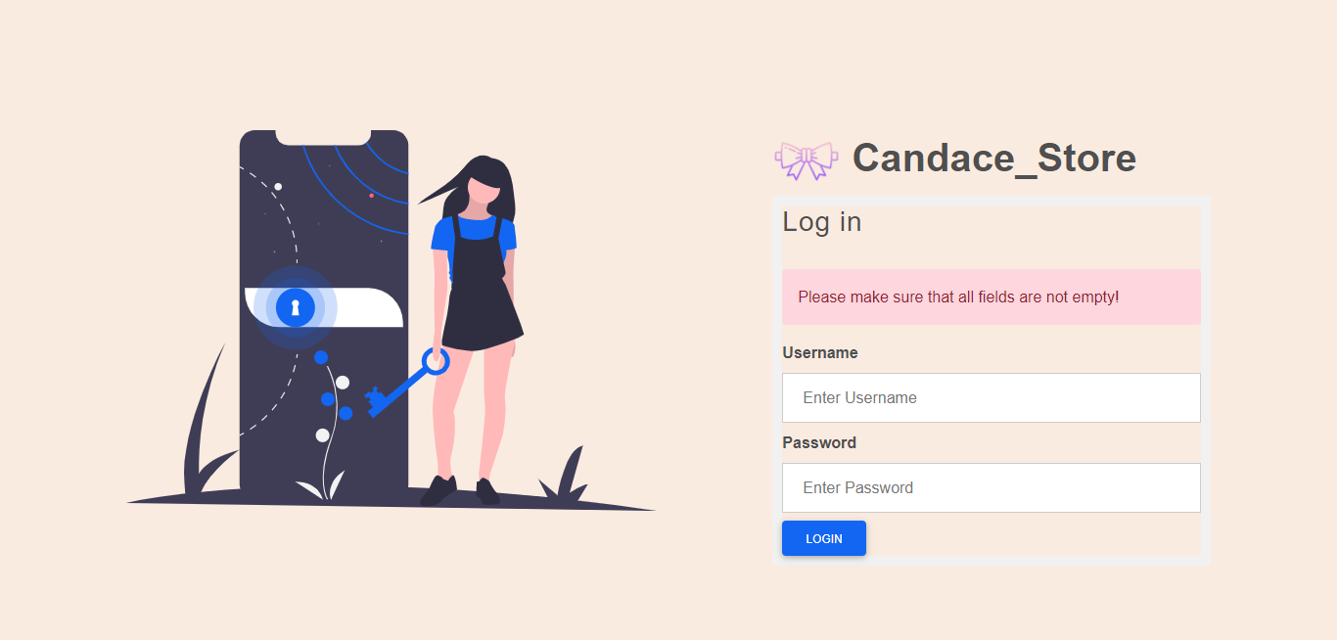

**(Figure 1.2 - login with not exist user name)**

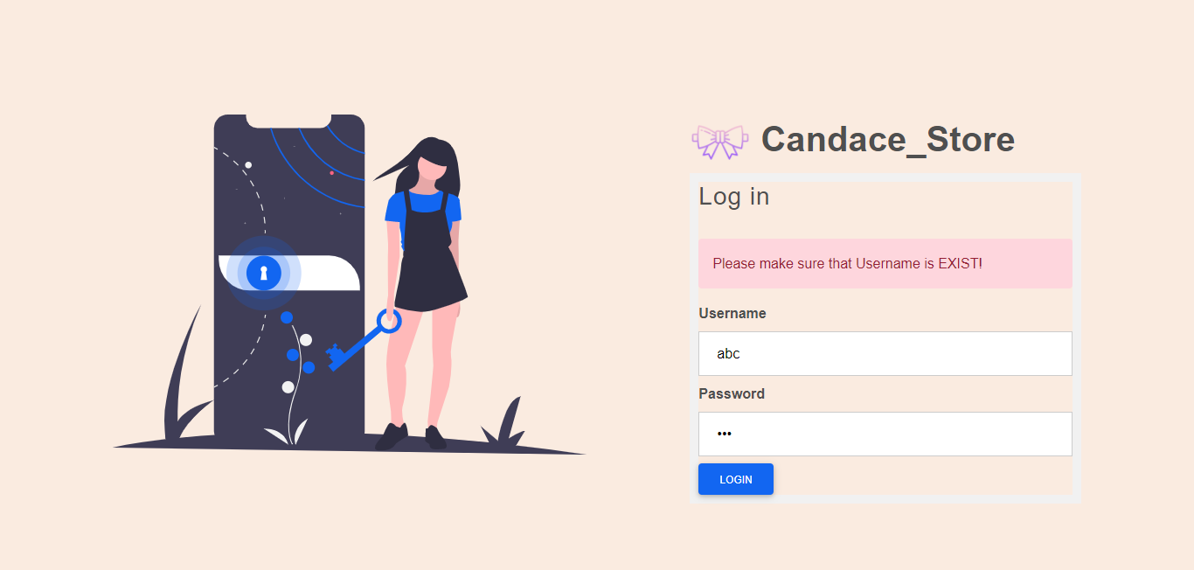

**(Figure 1.3 - login with exist user name but wrong password)**

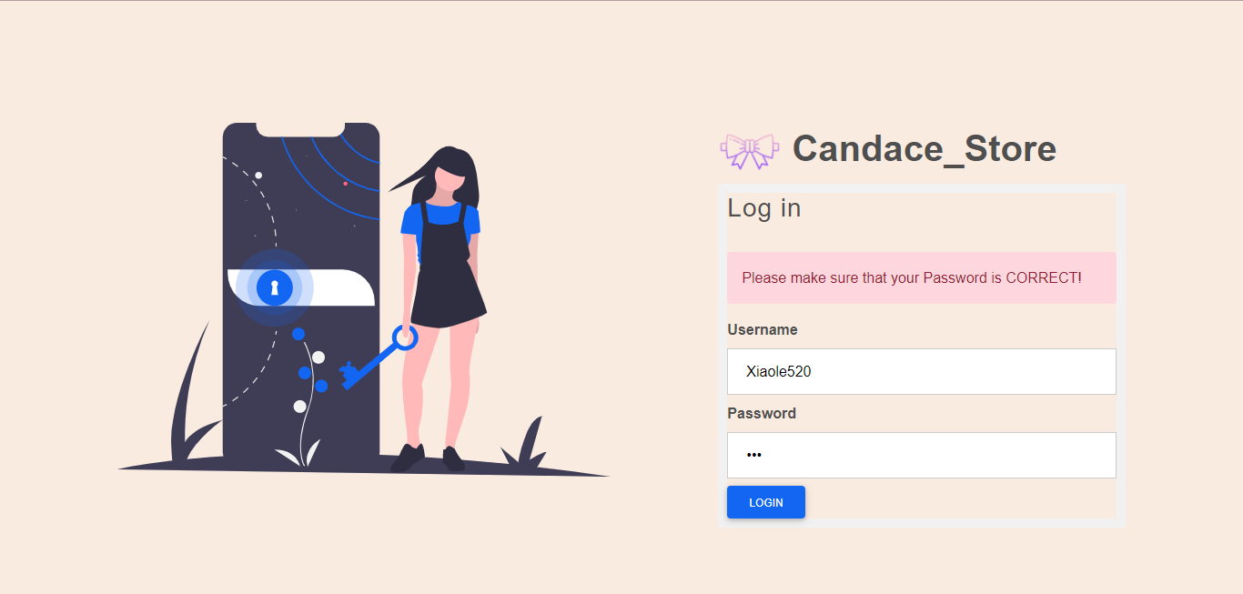

**(Figure 1.4 - login with inactive account)**

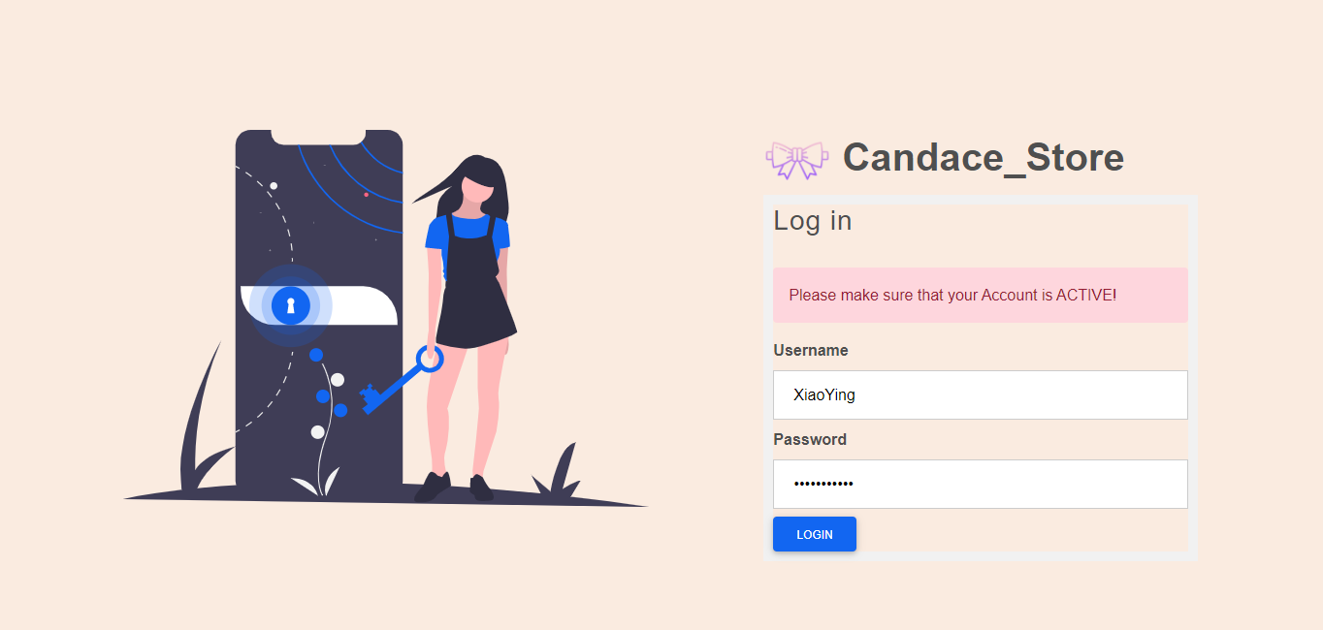

**(Figure 1.5 - try to redirect to another page(home page) without login)**

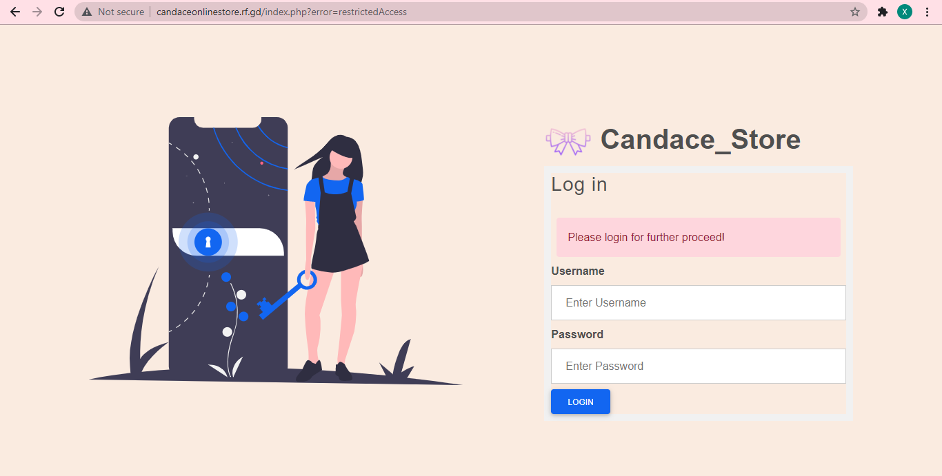

**(Figure 1.6 - login with exist username, correct password and active account)**



**(Figure 2.2 Change name(Hi (name)due to difference user name))**





**(Figure 2.3 - Product List Page)**

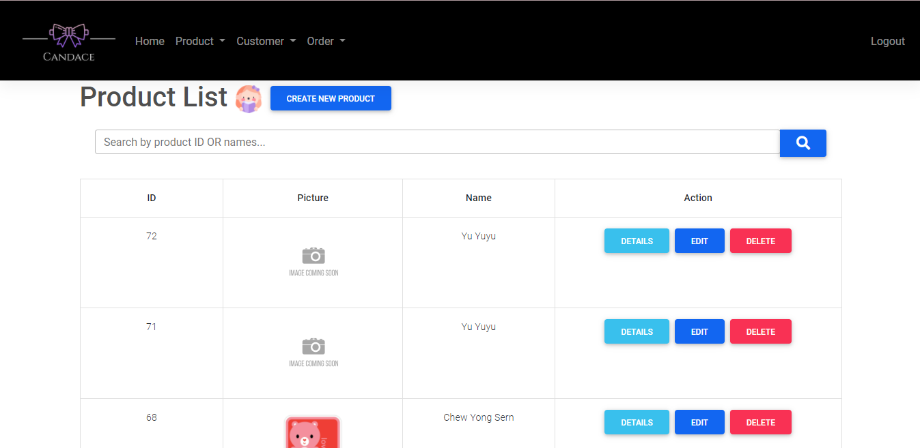

**(Figure 2.4 - Customer List Page)**

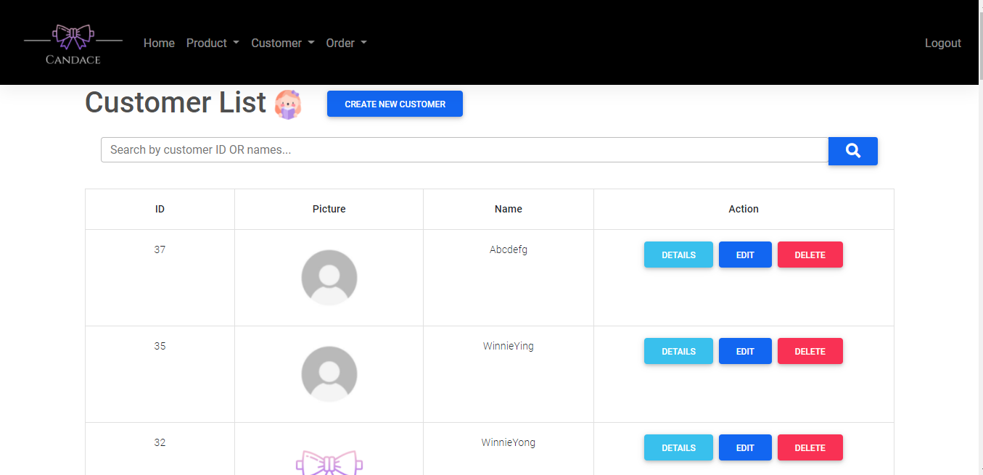

**(Figure 2.5 - Order List Page)**

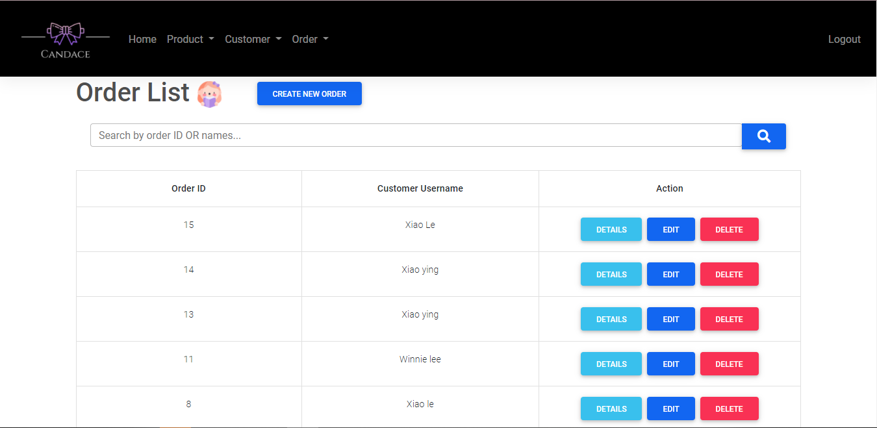

**(Figure 2.6 - Latest Order Summary)**

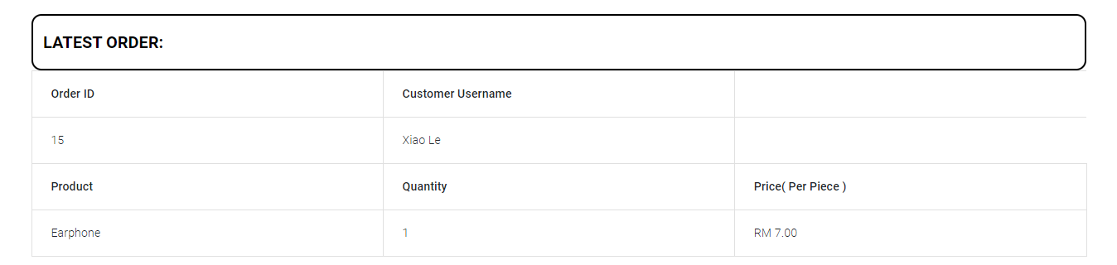

**(Figure 2.7 - Highest purchase amount order summary)**

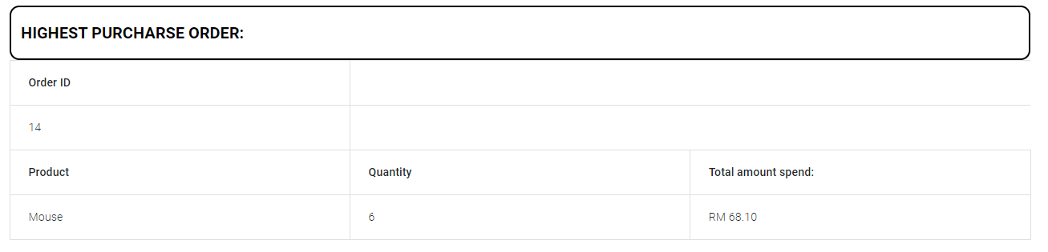

**(Figure 2.8 - top 5 selling products)**

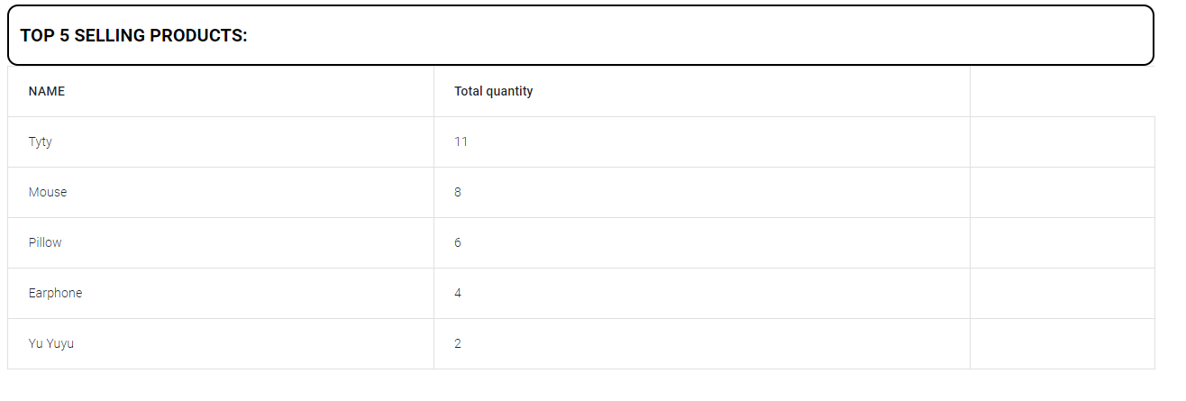

**(Figure 3.1 - Create Product Page)**

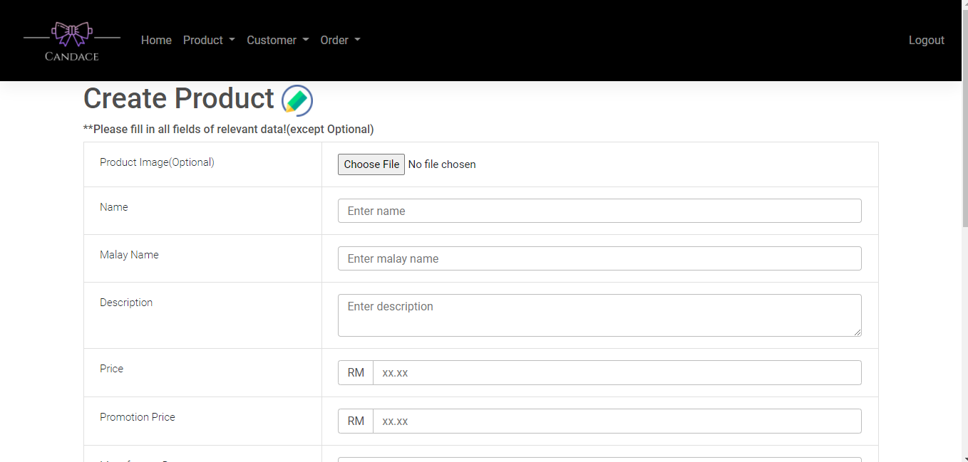

**(Figure 3.2 - Without fill in all field in Create Product Page)**

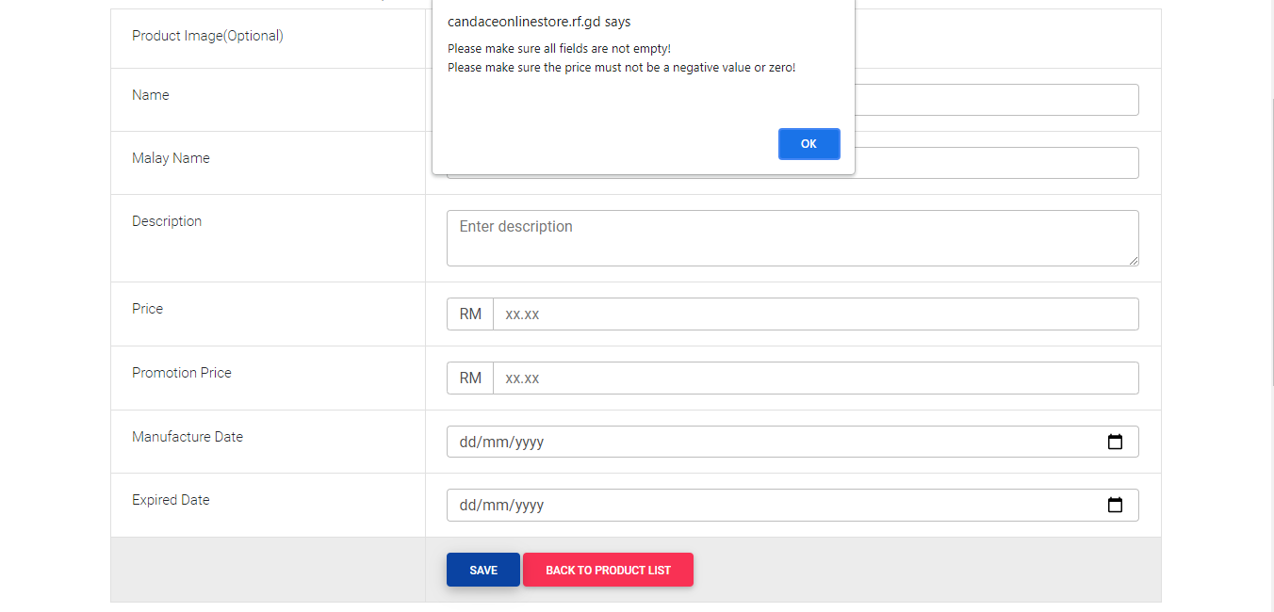

**(Figure 3.3 - Fill in price in not number format in Create Product Page)**

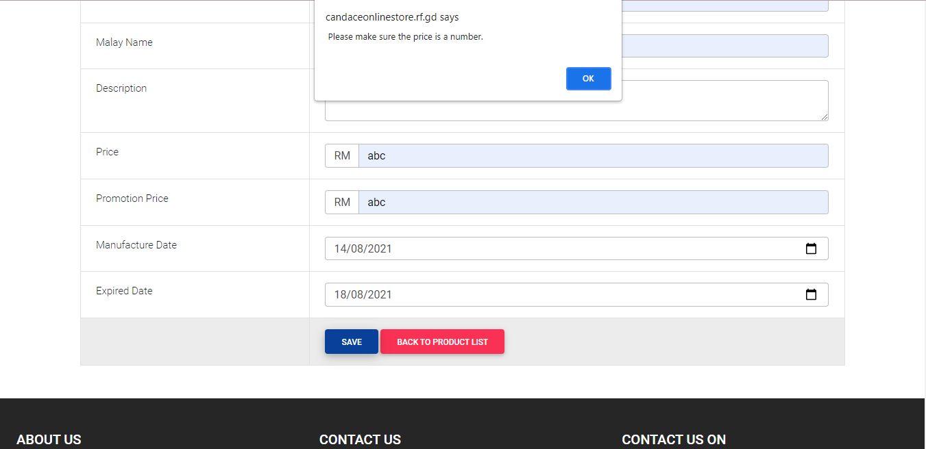

**(Figure 3.4 - Fill in price in 0 or smaller than 0 in Create Product Page)**

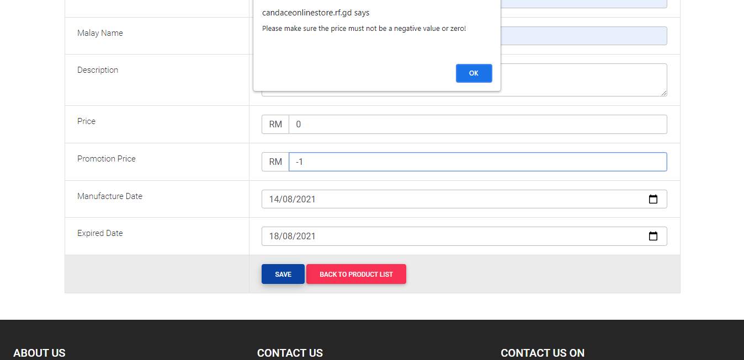

**(Figure 3.5 - Fill in price larger than RM1000 in Create Product Page)**

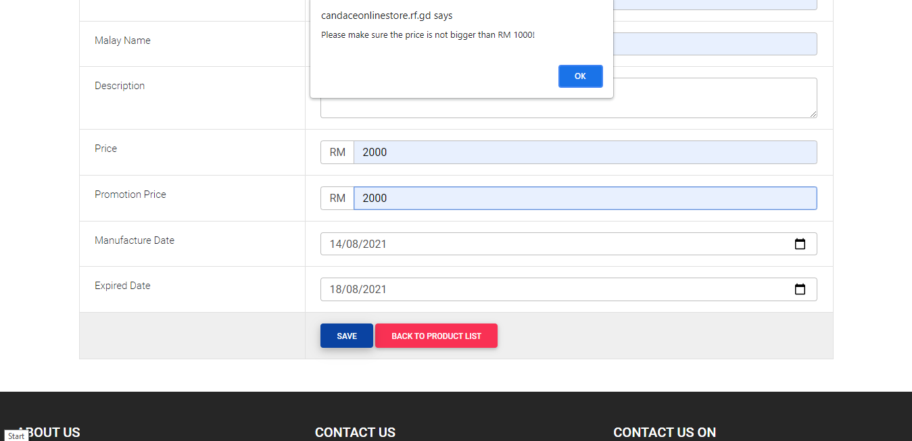

**(Figure 3.6 - Fill in promotion price larger than price in Create Product Page)**

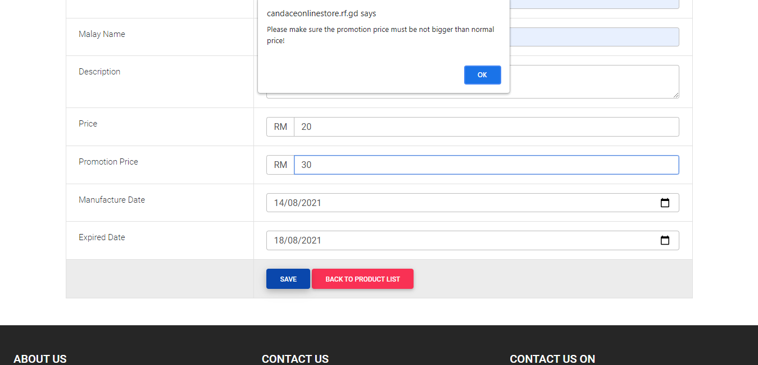

**(Figure 3.7 - Fill in manufacture date later than expired date in Create Product Page)**

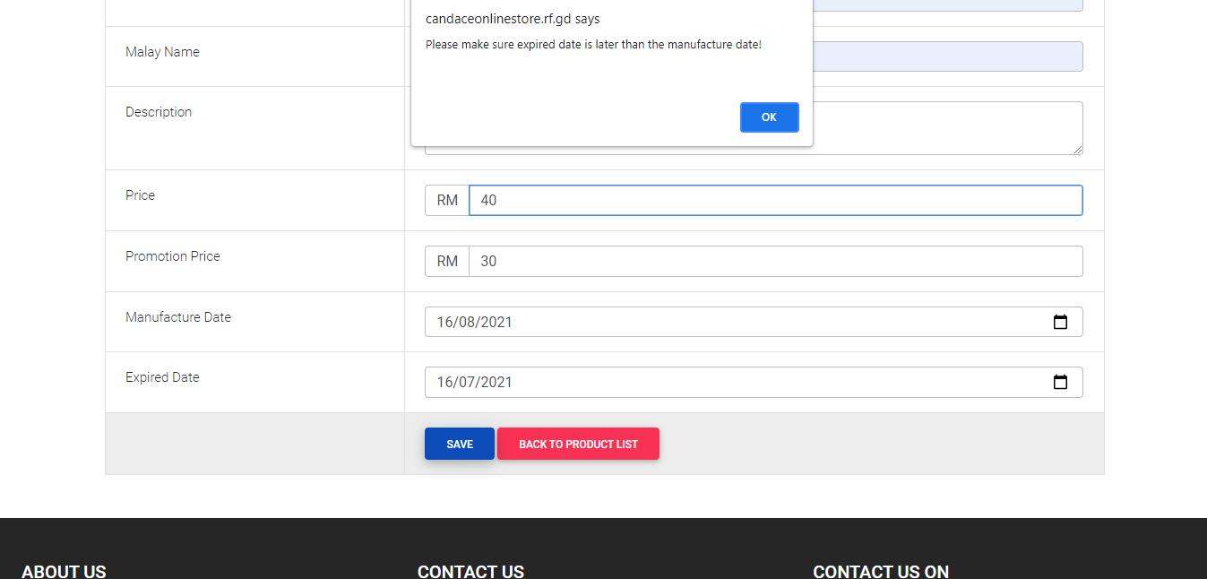

**(Figure 3.8 - Upload non image file in product image field in Create Product Page)**

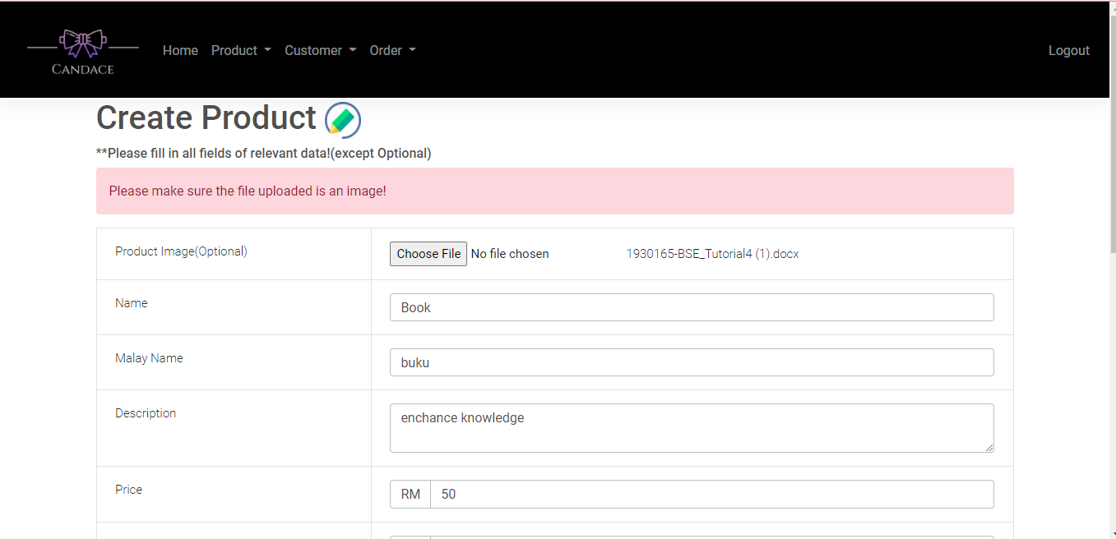

**(Figure 3.9 - Upload image file which width is not same as height in product image field in Create Product Page)**

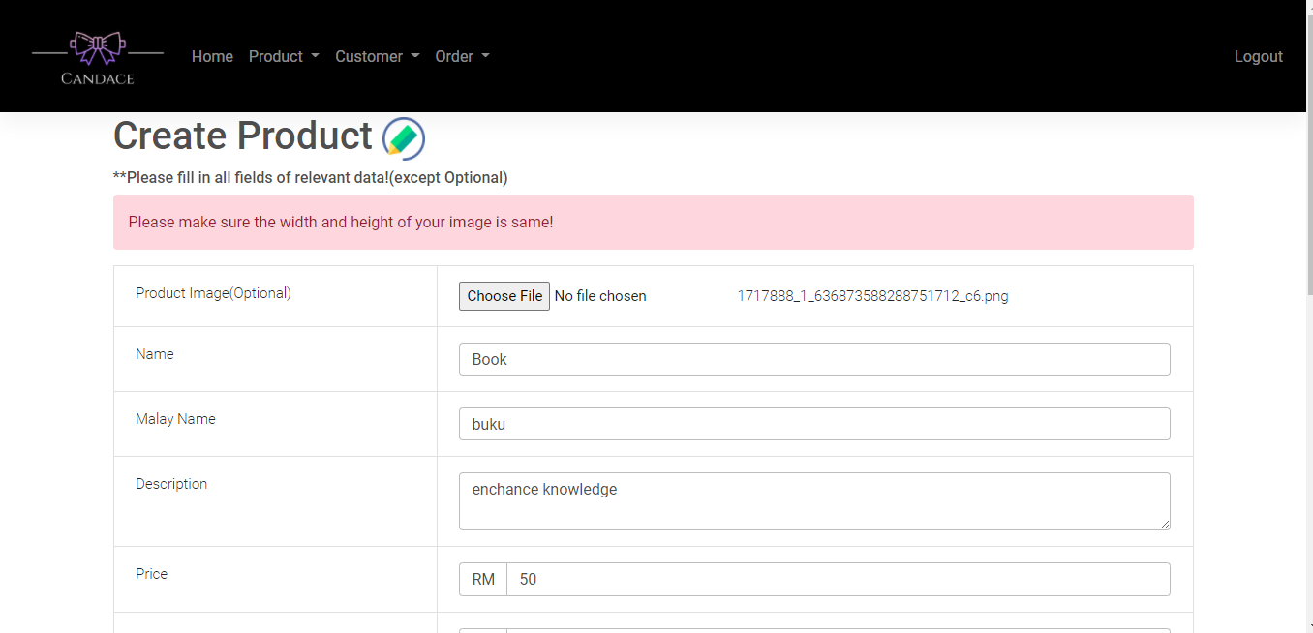

**(Figure 3.10 - Upload image file which size larger than 512kb in product image field in Create Product Page)**

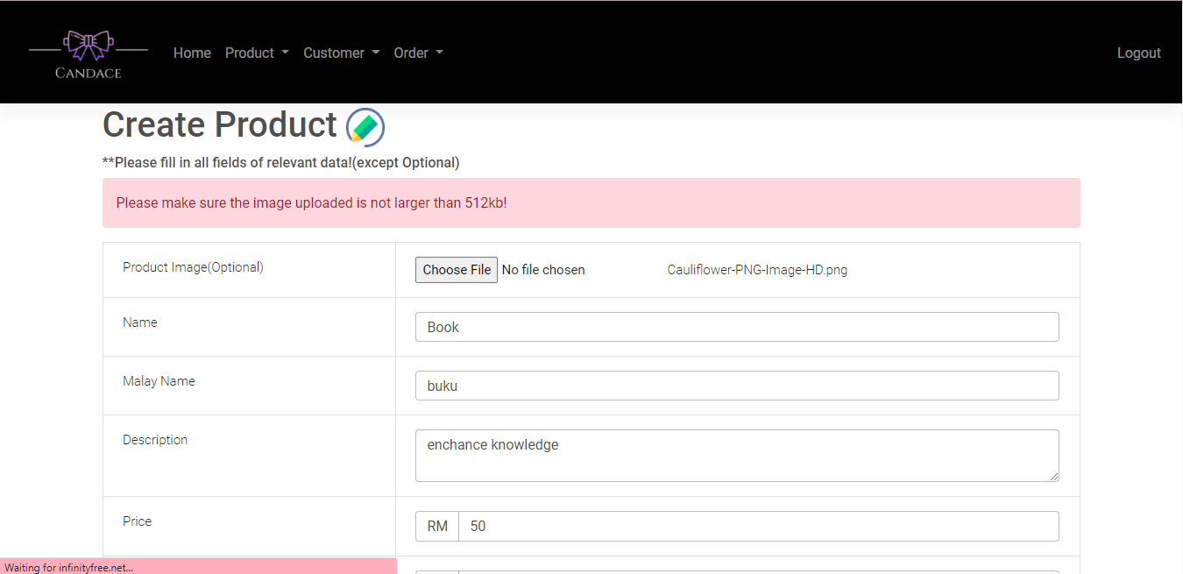

**(Figure 3.11- Fill in every field without any error in Create Product Page)**

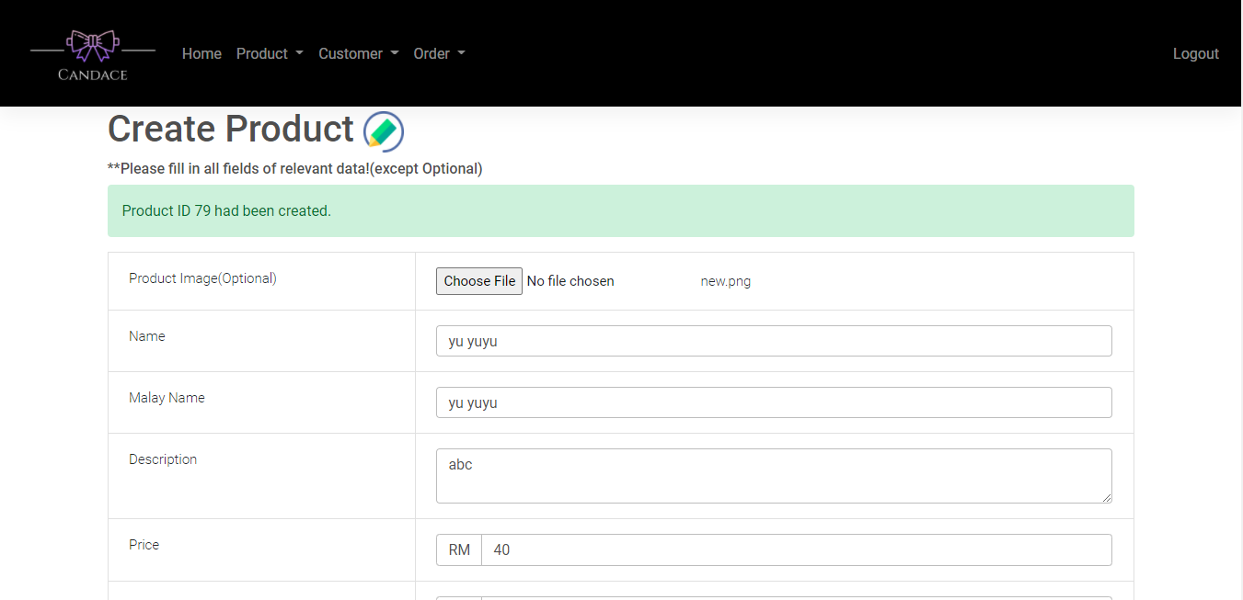

**(Figure 3.12 - Direct to Product List Page)**

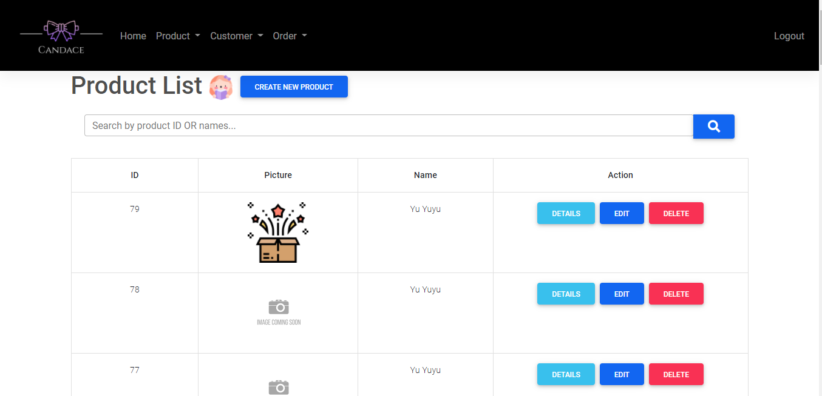

**(Figure 4.2 - Search by product ID (eg:54) in Product List Page)**

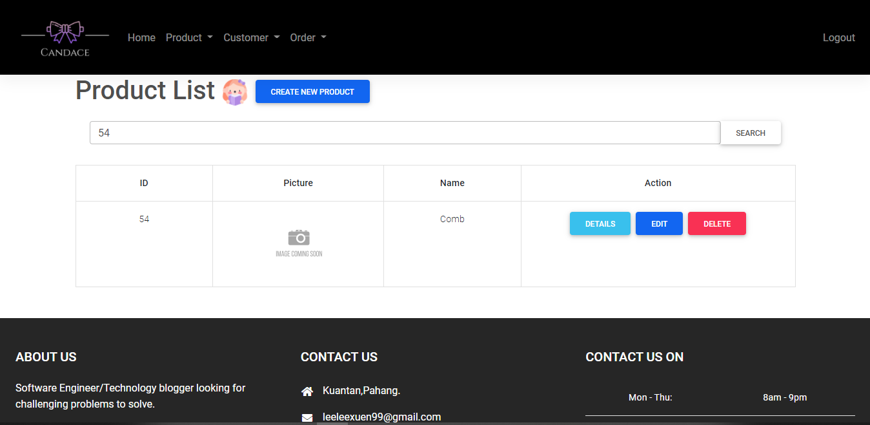

**(Figure 4.2 - Search by product name (eg:Comb) in Product List Page)**

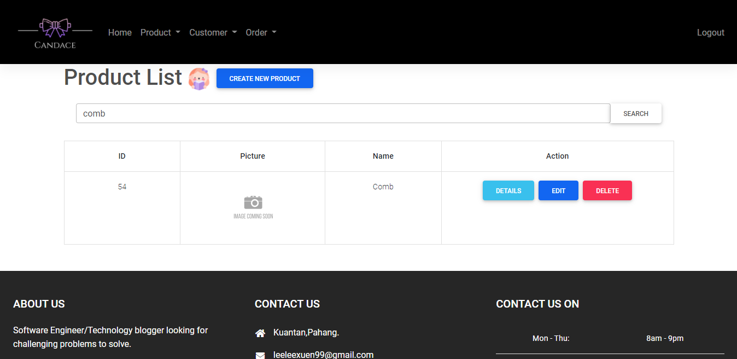

**(Figure 4.3 - Search by wrong product id(eg:55) in Product List Page)**

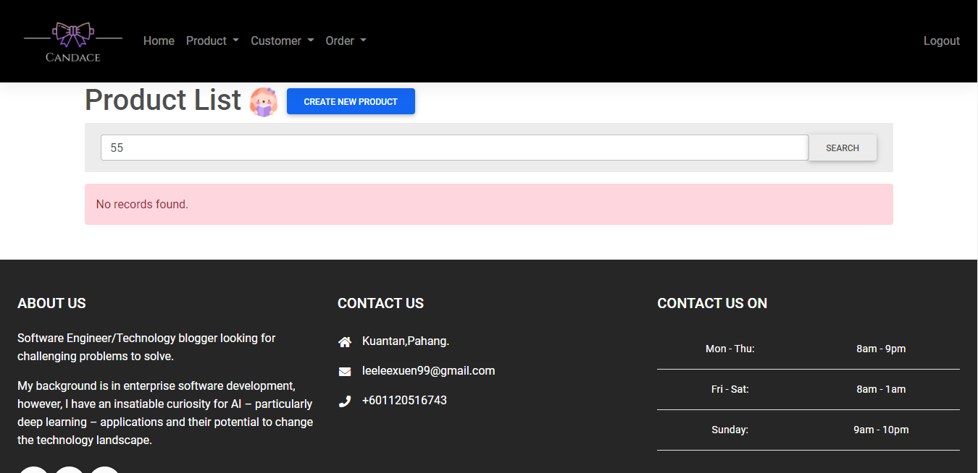

**(Figure 4.3 - Search by wrong product name(eg:combi) in Product List Page)**

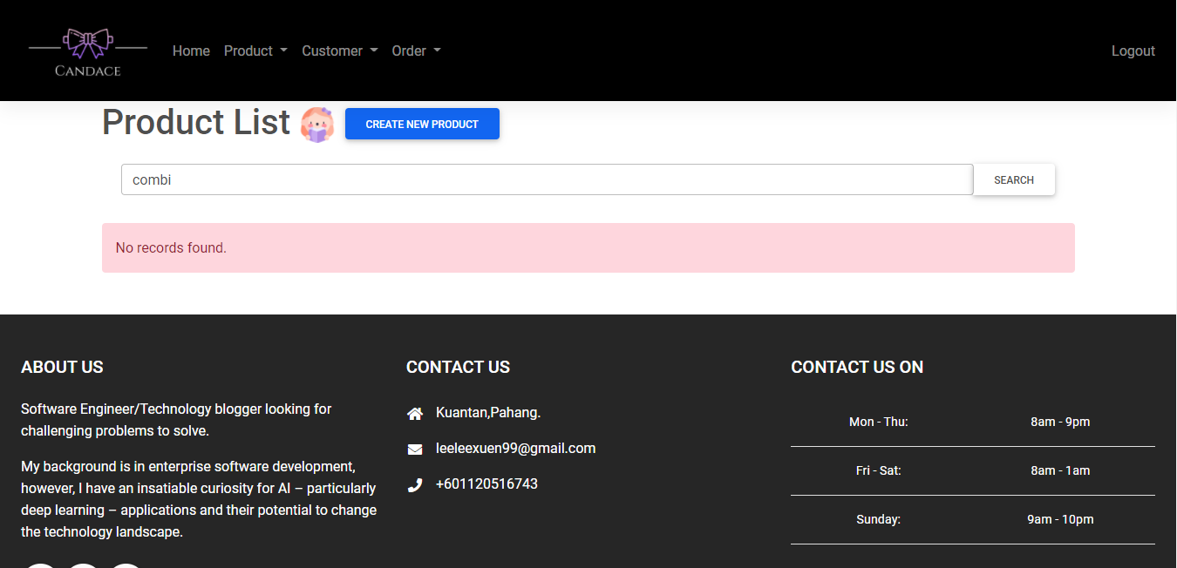

**(Figure 4.4 - Come to Product Details Page)**

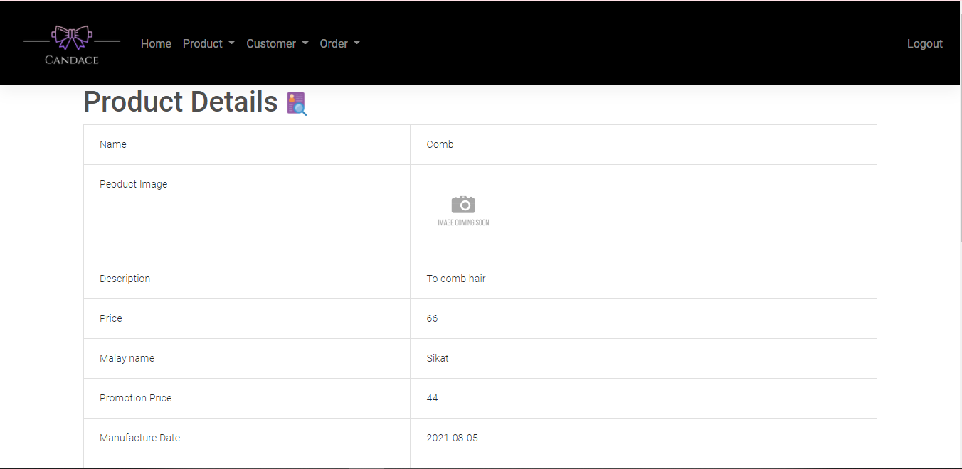

**(Figure 4.5 - Come to Product Edit Page)**

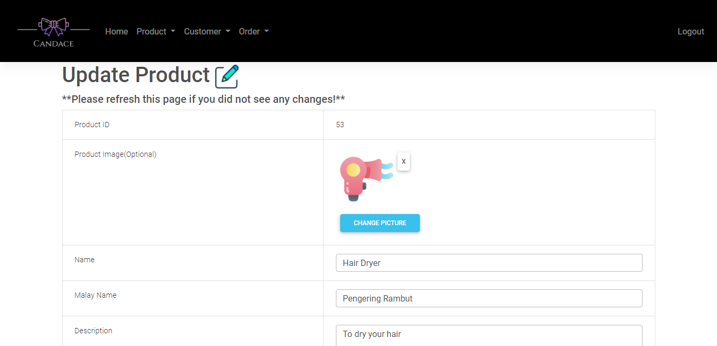

**(Figure 4.6 - Delete product which not in order(eg: book) Product List Page)**

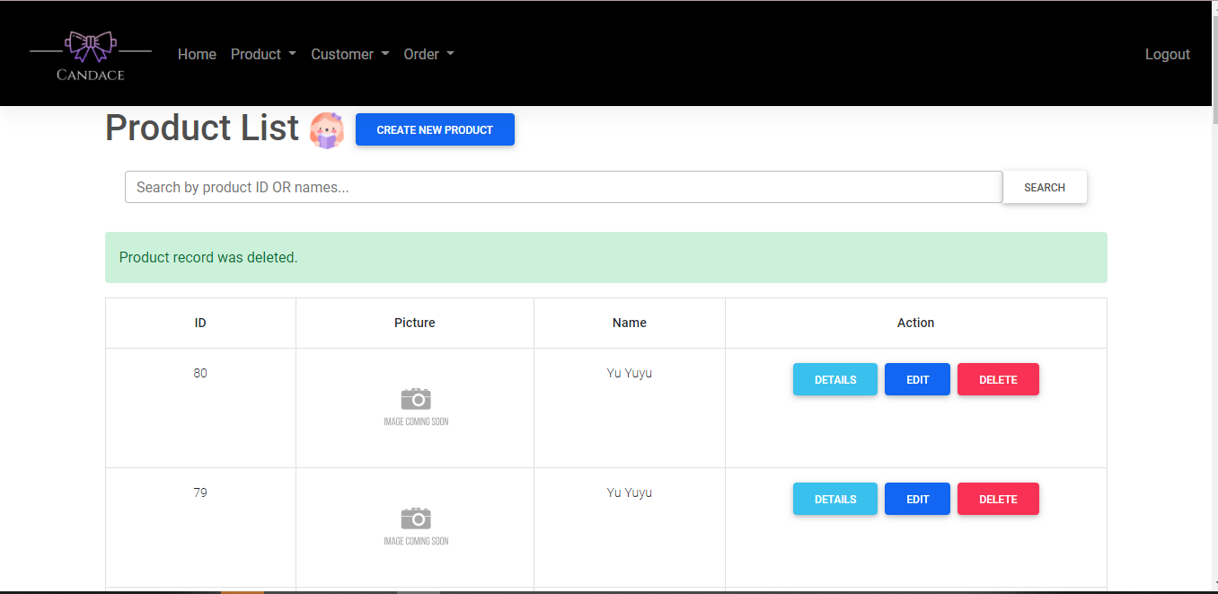

**(Figure 4.7 - Delete product which in order(eg: hair dryer) Product List Page)**

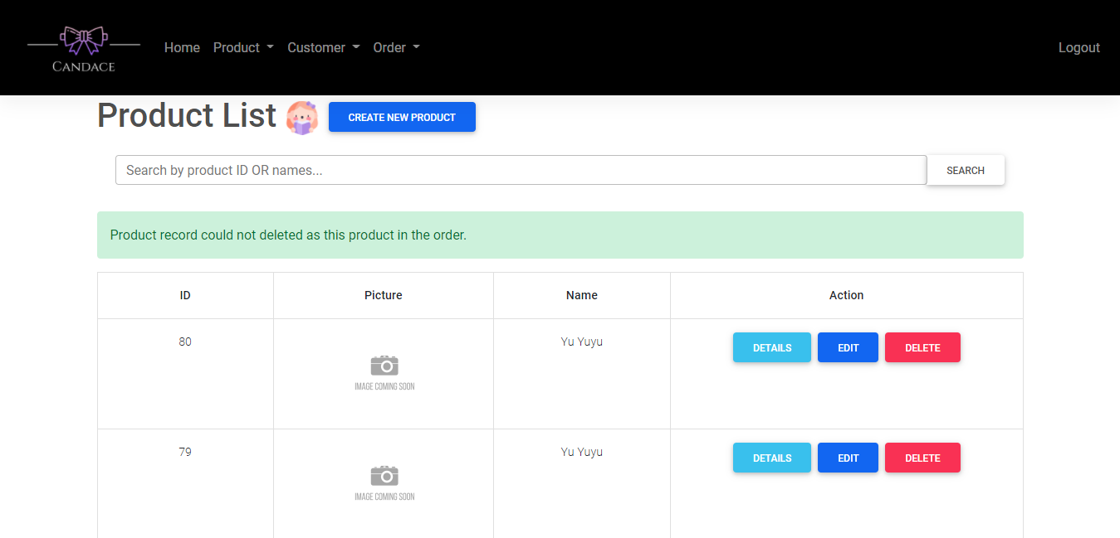

**(Figure 6.1 - Without filling all fields in Product Edit Page)**

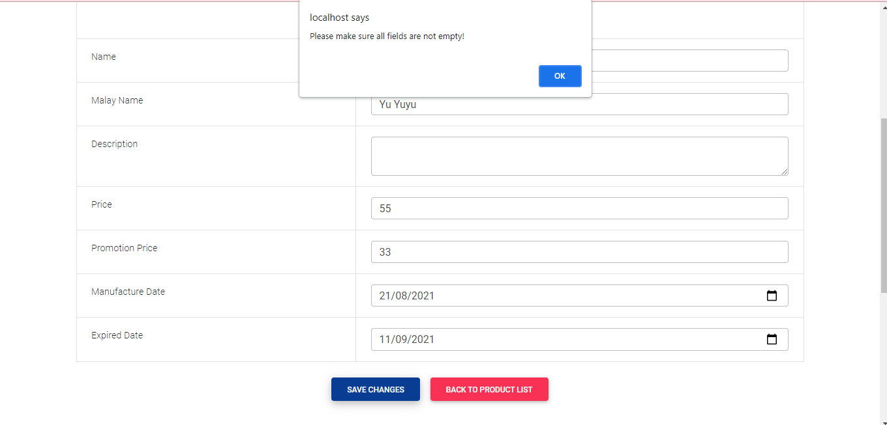

**(Figure 6.2 -Upload an non-image file in the field of product image in Product Edit Page)**

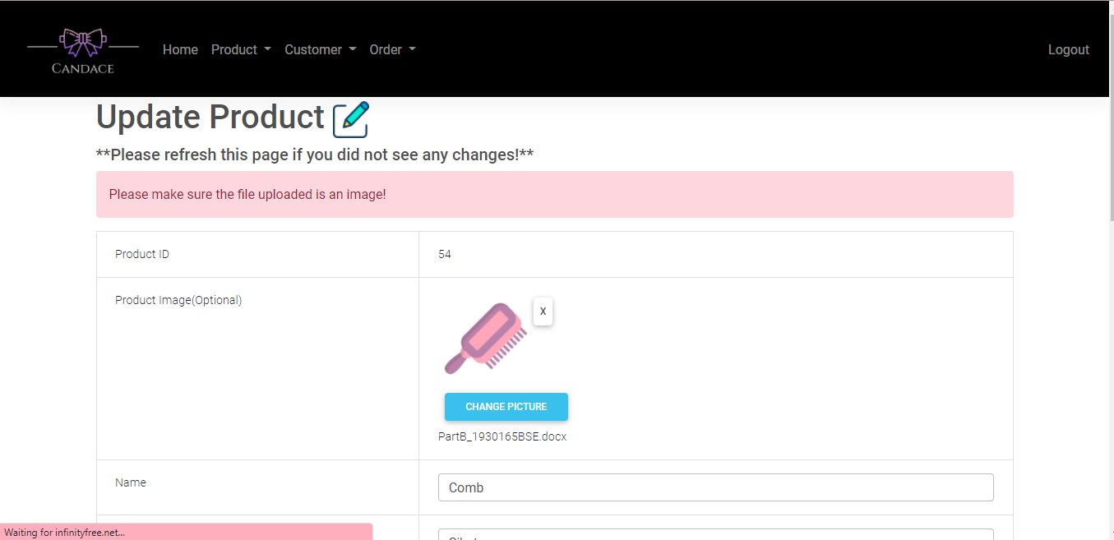

**(Figure 6.3 -Upload an image file which width and height is not the same in the field of product image in Product Edit Page)**

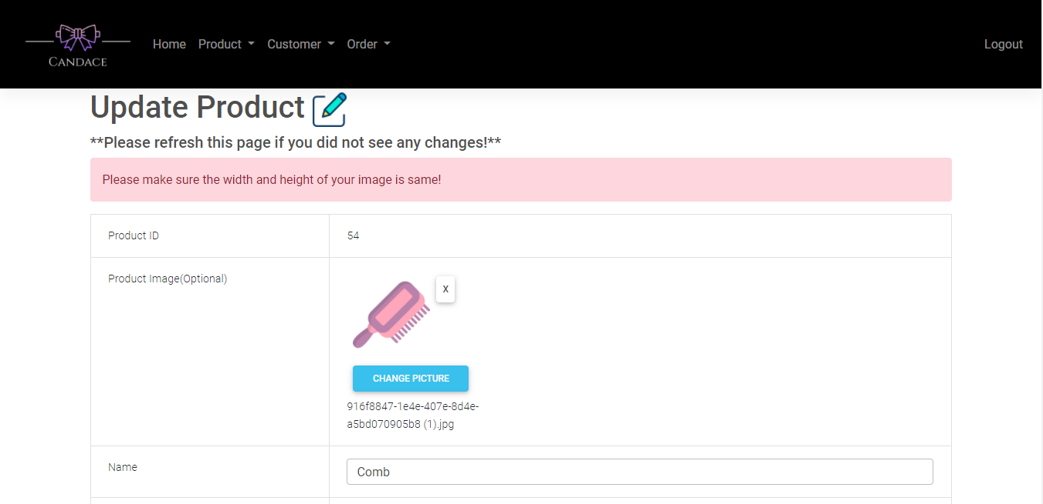

**(Figure 6.4 -Upload an image file which size larger than 512kb in the field of product image in Product Edit Page)**

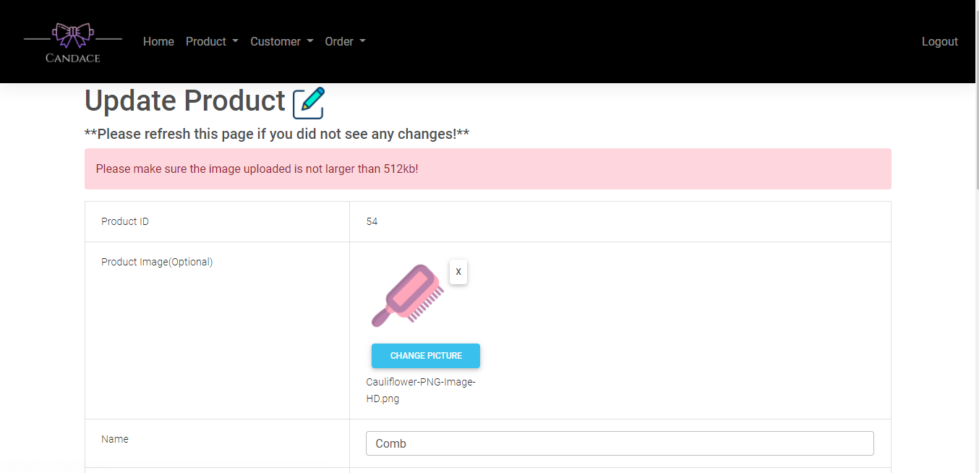

**(Figure 6.5 - Fills in the value which is zero or smaller than zero in price or promotion fields in Product Edit Page)**

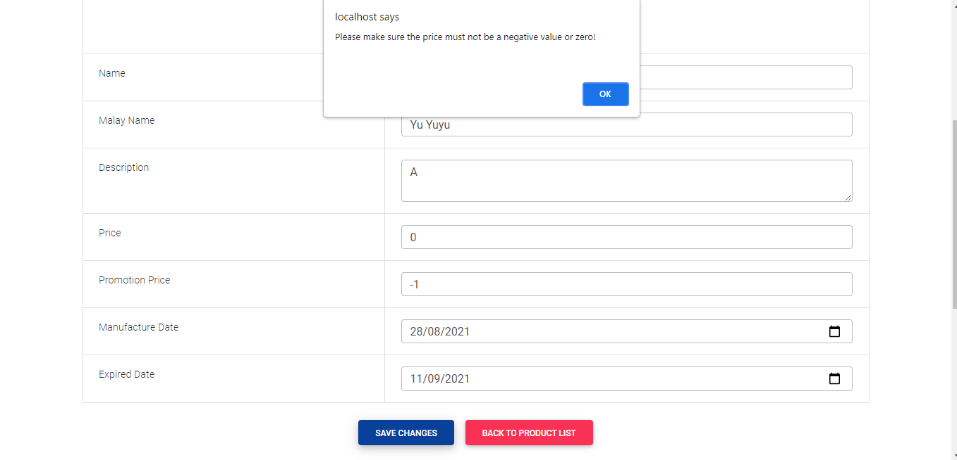

**(Figure 6.6 - Fills in the field of manufacture date which is later than expired date in Product Edit Page)**

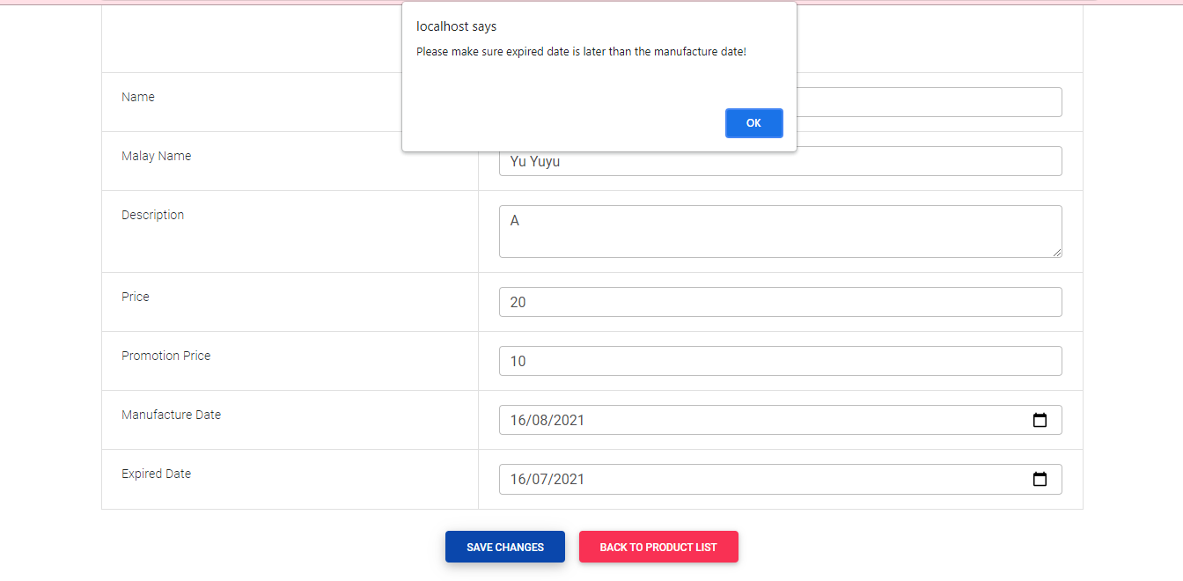

**(Figure 6.7 -Fills in the price or promotion fields which larger than RM1000 in Product Edit Page)**

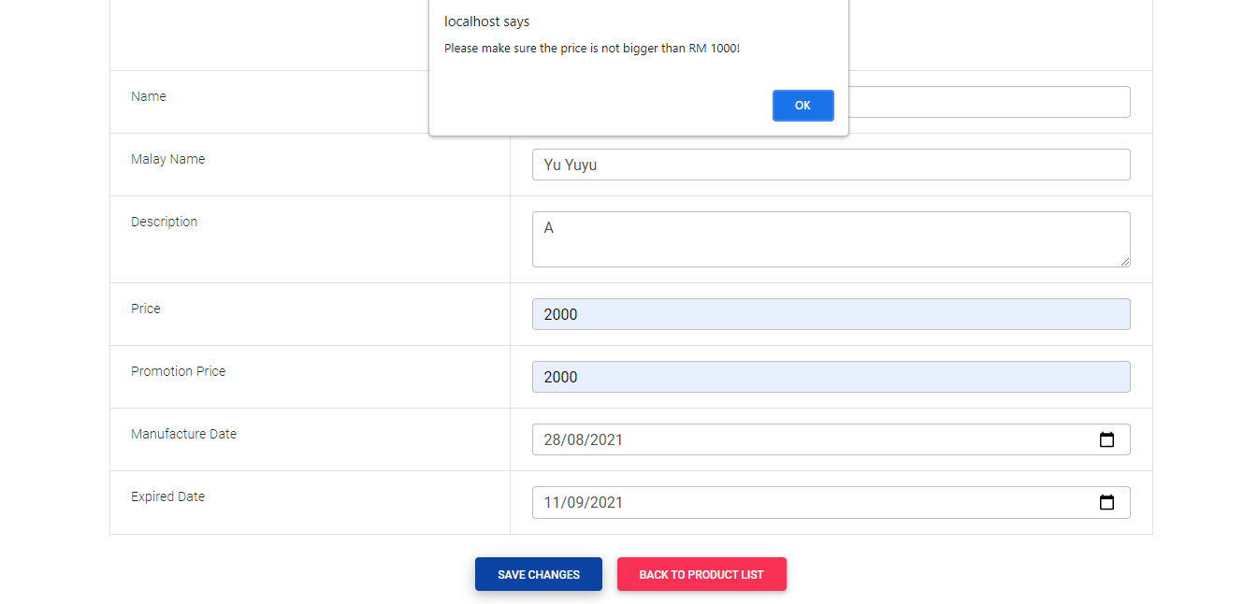

**(Figure 6.8 -Fills in the price or promotion fields which in number format in Product Edit Page)**

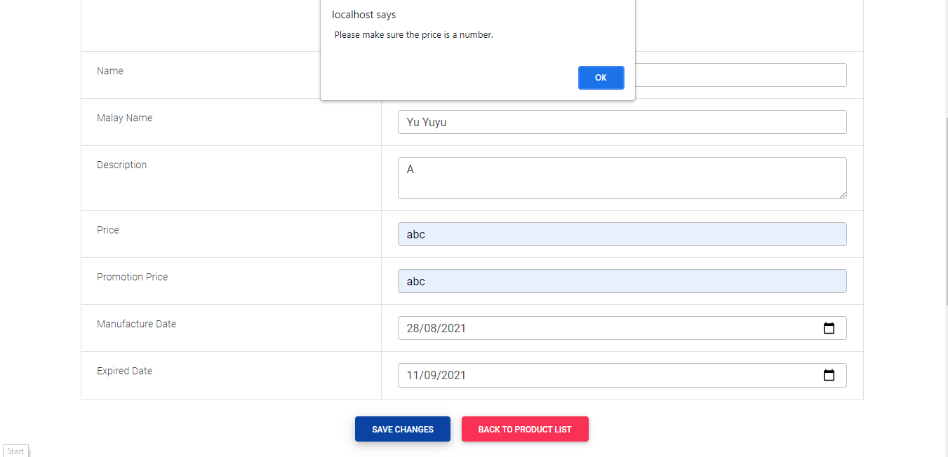

**(Figure 6.9 -Fills in all the fields without any error in Product Edit Page)**

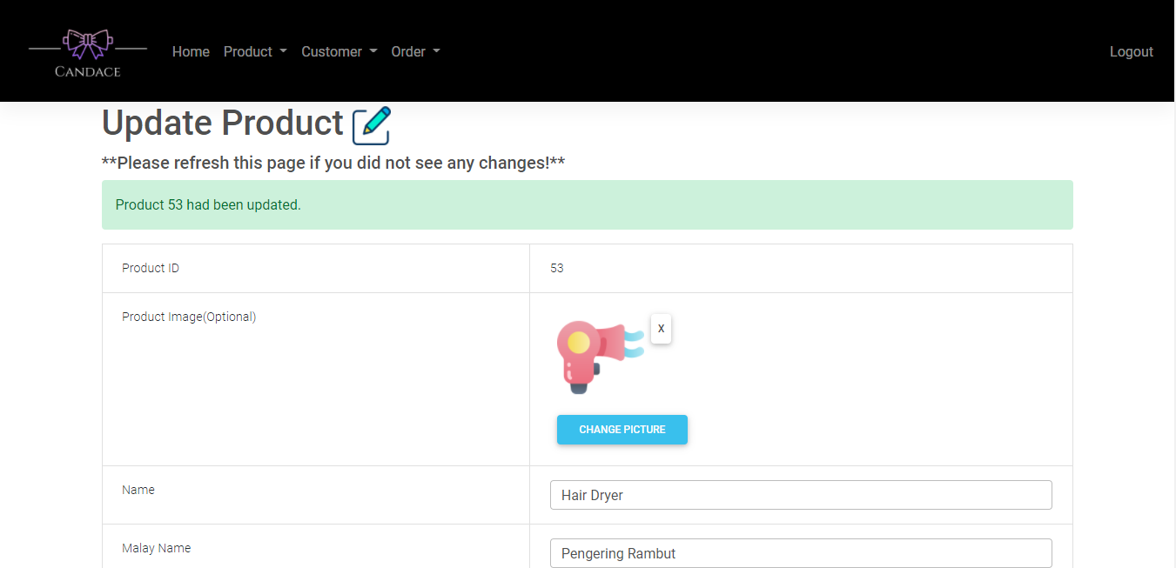

**(Figure 6.10 -Delete an existing image in Product Edit Page)**

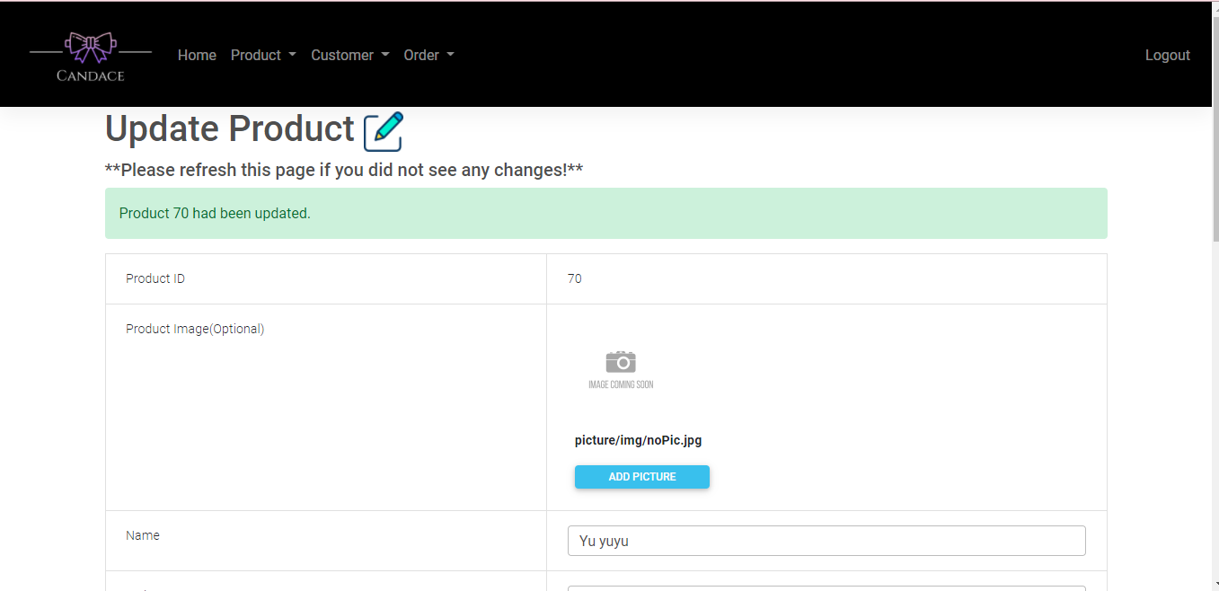

**(Figure 7.1 - Come to Create Customer Page)**

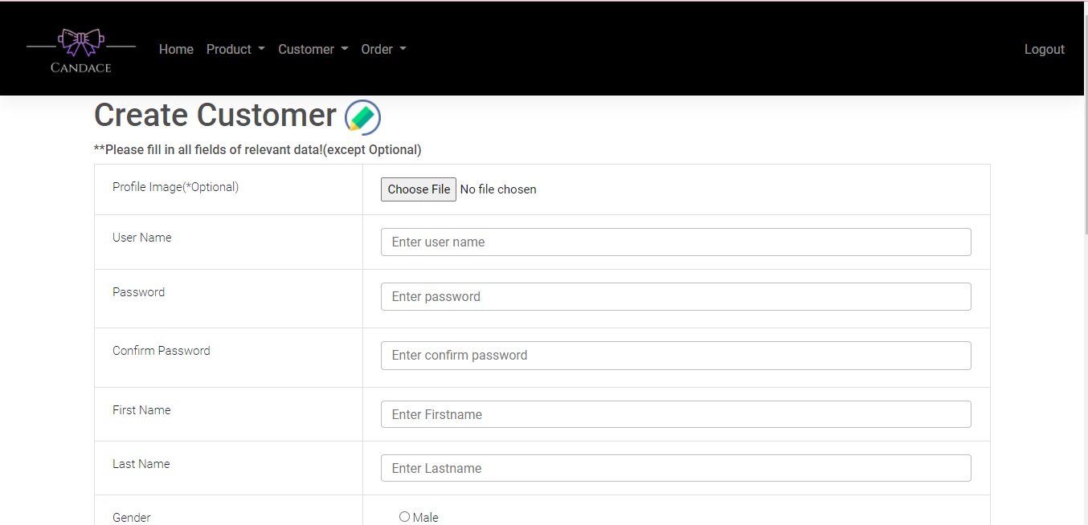

**(Figure 7.2 - Without filling all fields in Create Customer Page)**

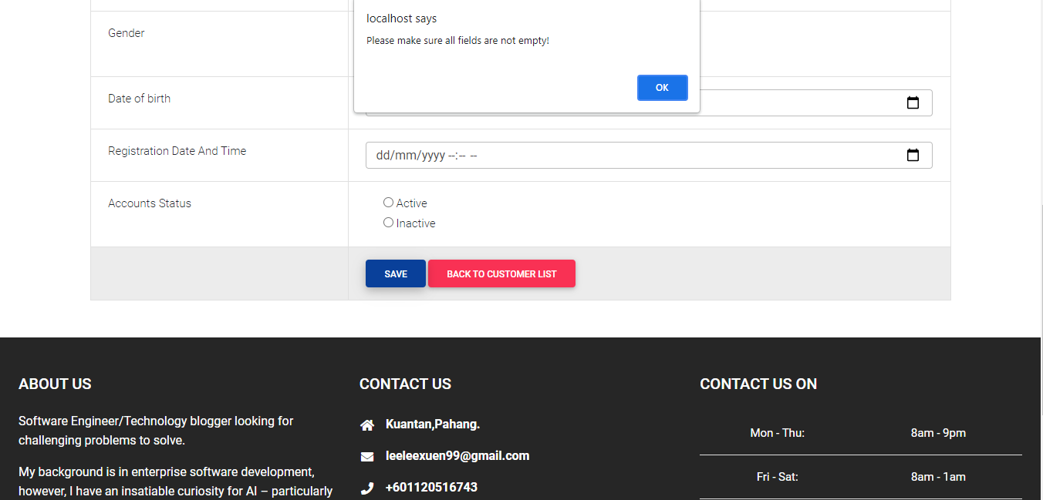

**(Figure 7.3 - filling name with number of character which smaller than 6 or larger than 15 in Create Customer Page)**

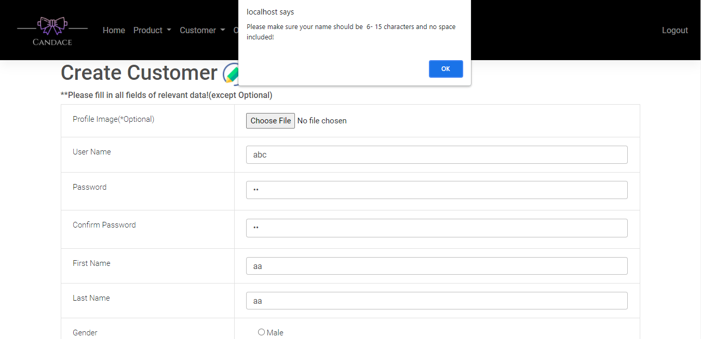

**(Figure 7.4 - filling the name field with an existing name all fields in Create Customer Page)**

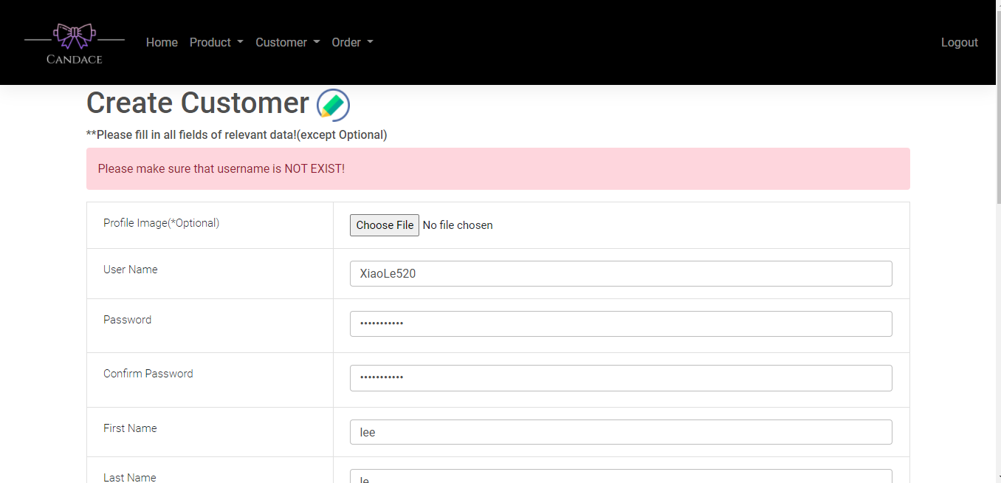

**(Figure 7.5 - filling password not same as confirm password in Create Customer Page)**

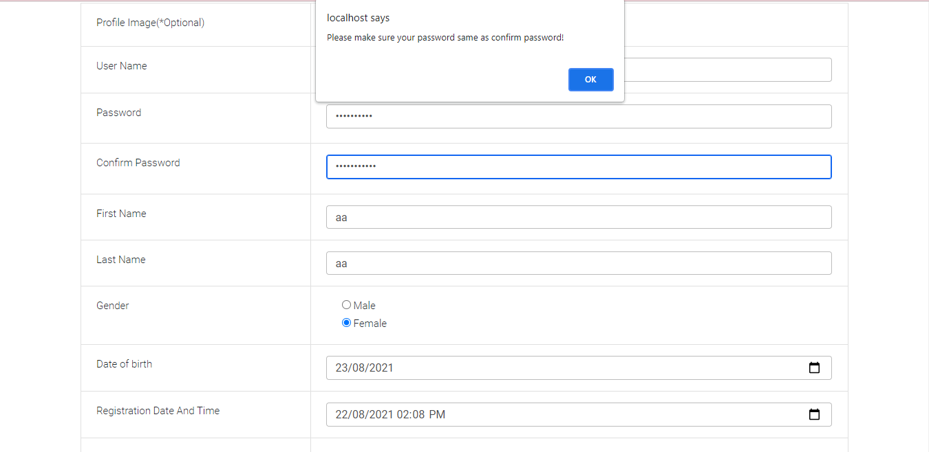

**(Figure 7.6 - filling password of confirm password field not fulfilling the condition of contain at least one lowercase letter, one uppercase letter, one numeric digit and one special character in at least 8 characters in Create Customer Page)**

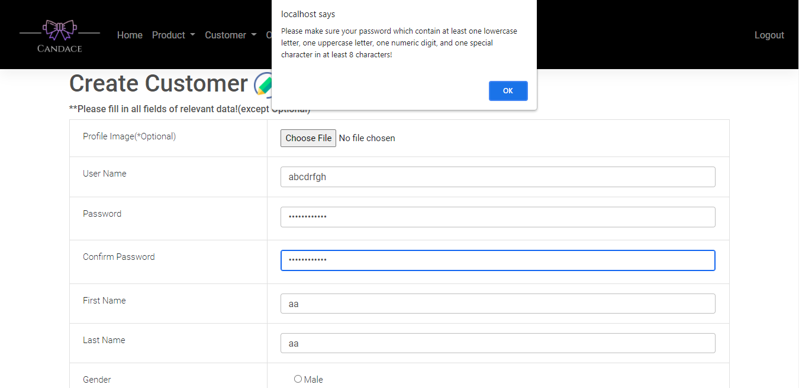

**(Figure 7.7 - filling fields of date of birth with age lower than 18 years old in Create Customer Page)**

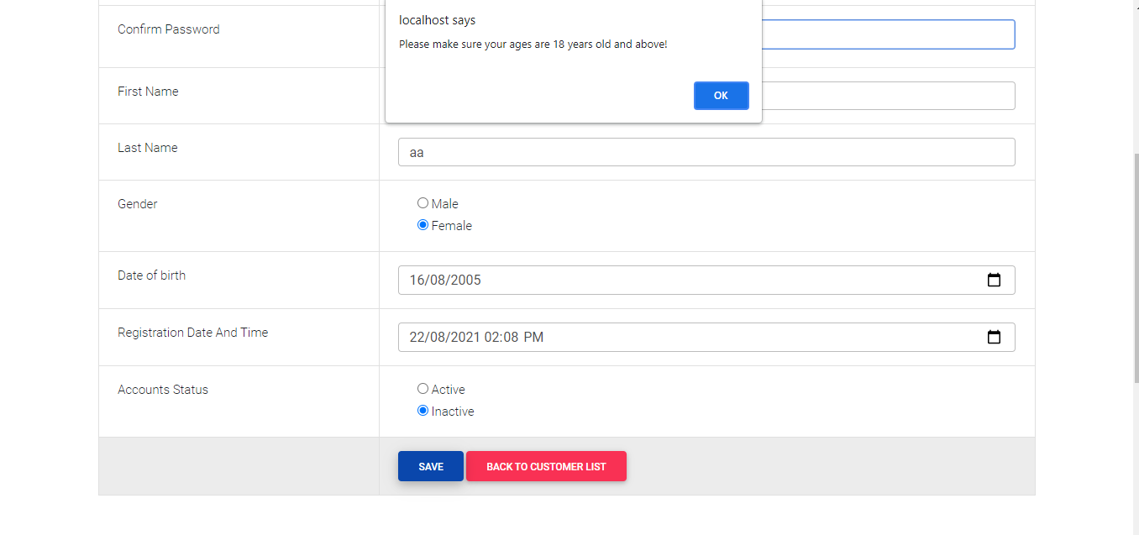

**(Figure 7.8 - upload non-image file in profile image fields in Create Customer Page)**

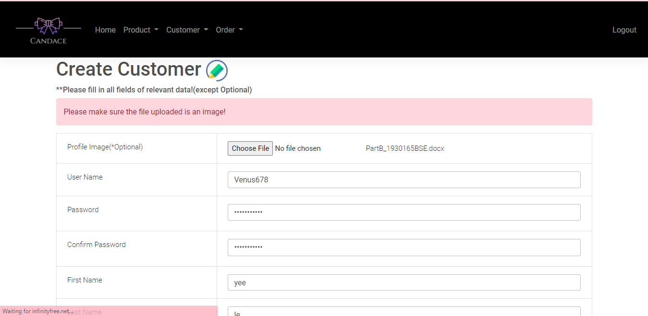

**(Figure 7.9 - upload image file which its width and height is not the same in Create Customer Page)**

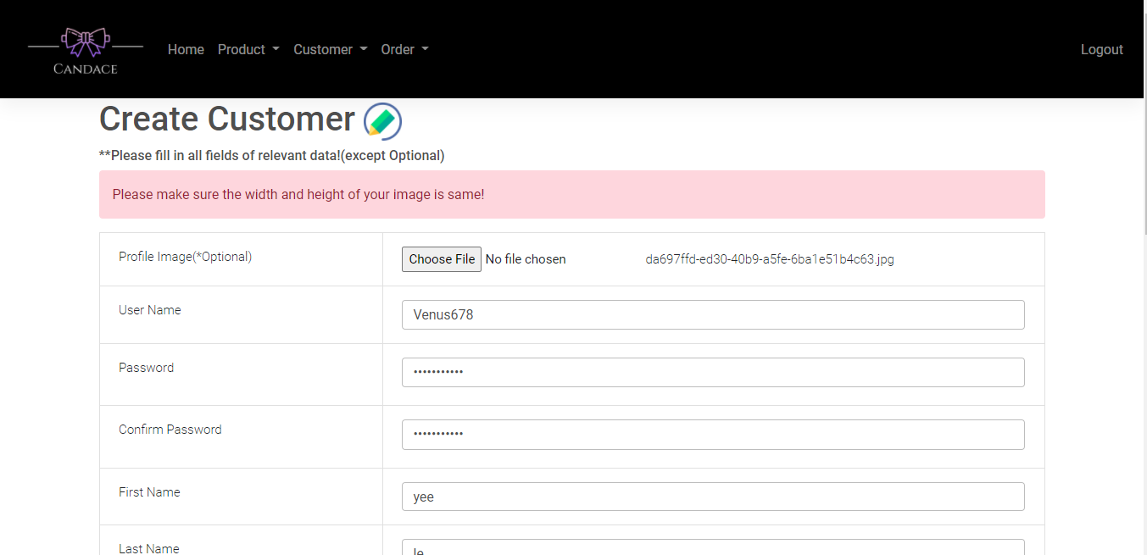

**(Figure 7.10 - upload image file which its size is larger than 512kb in Create Customer Page)**

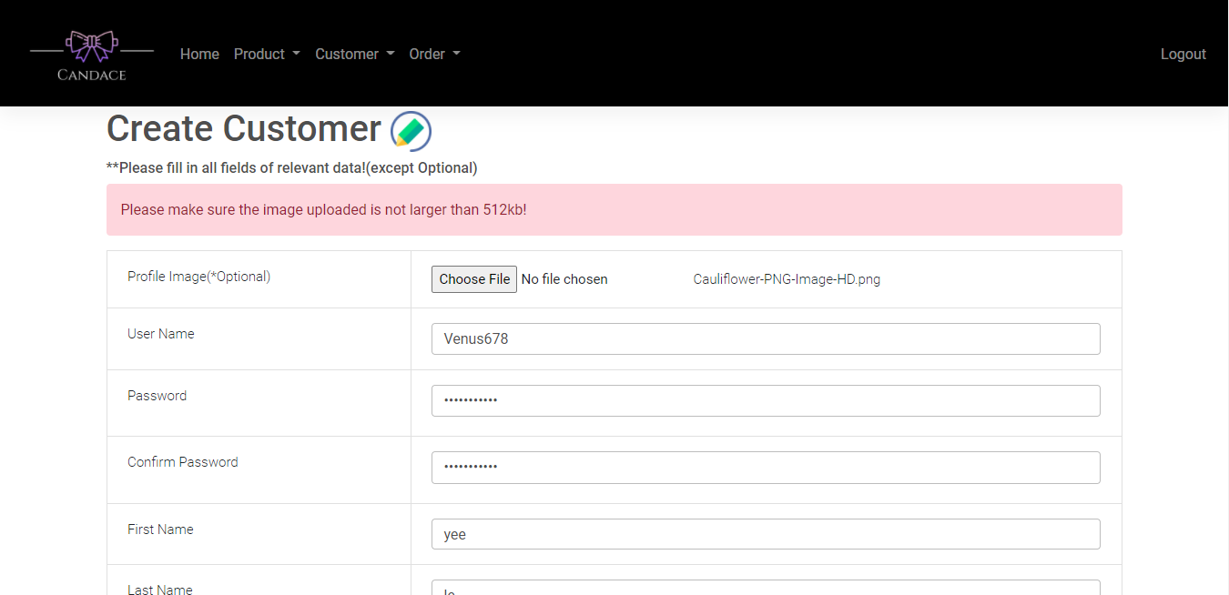

**(Figure 7.11 - filling all the field without any error in Create Customer Page)**

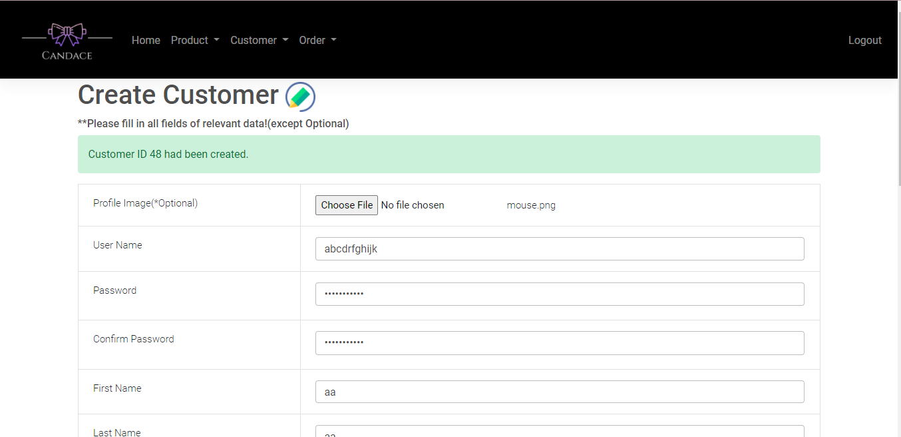

**(Figure 7.12 - Direct to Customer List Page)**

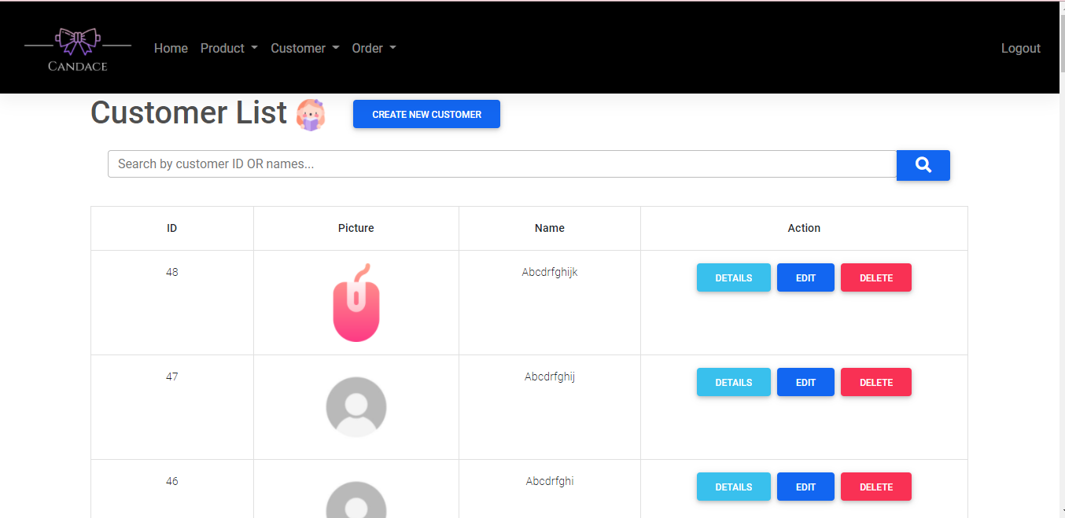

**(Figure 8.2 - Search the right id(eg:31) or names(eg:XiaoYing) in Customer List Page)**

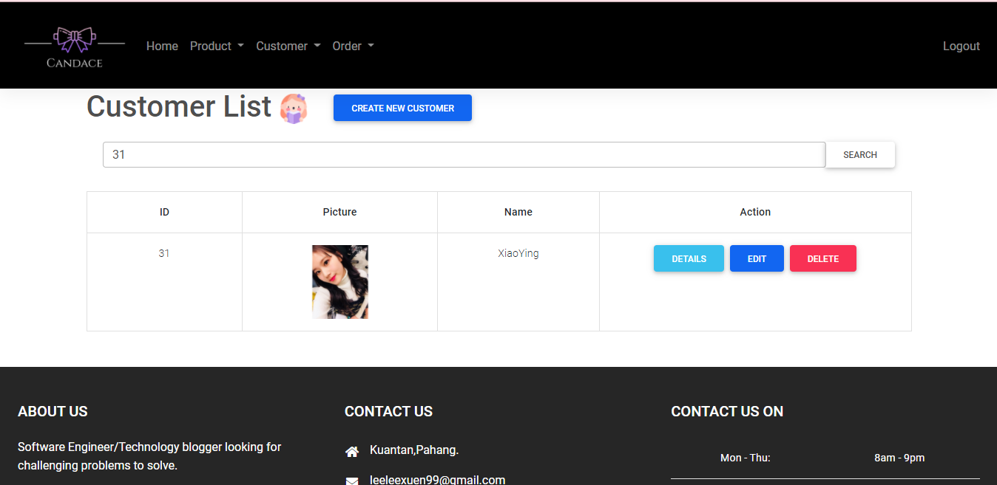

**(Figure 8.3 - Search the wrong id(eg:40) or names(eg:XiaoYingi) in Customer List Page)**

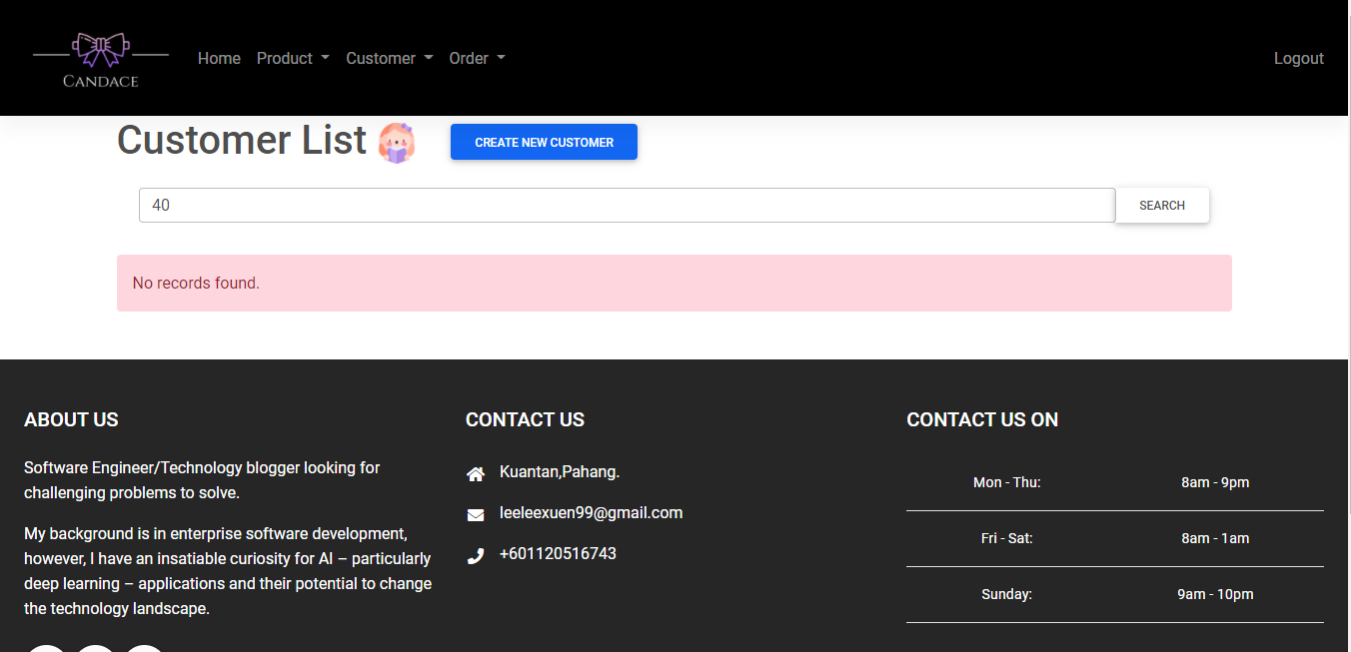

**(Figure 8.4 - Direct to Customer Details Page)**

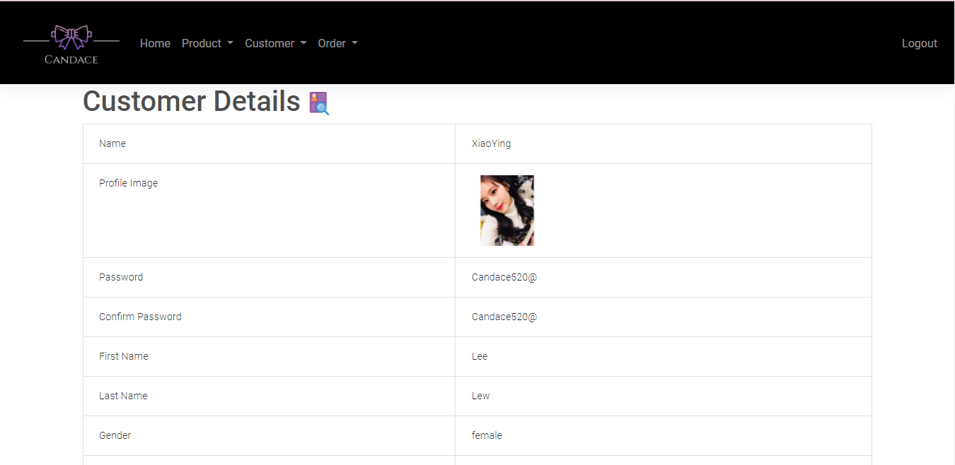

**(Figure 8.5 - Direct to Customer Edits Page)**

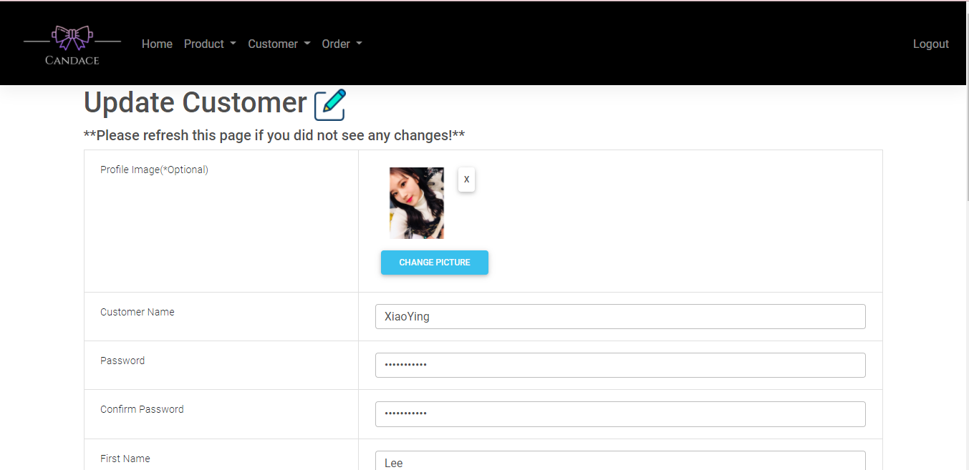

**(Figure 8.6 - Delete customer(eg:Winson789) which in order in Customer Edits Page)**

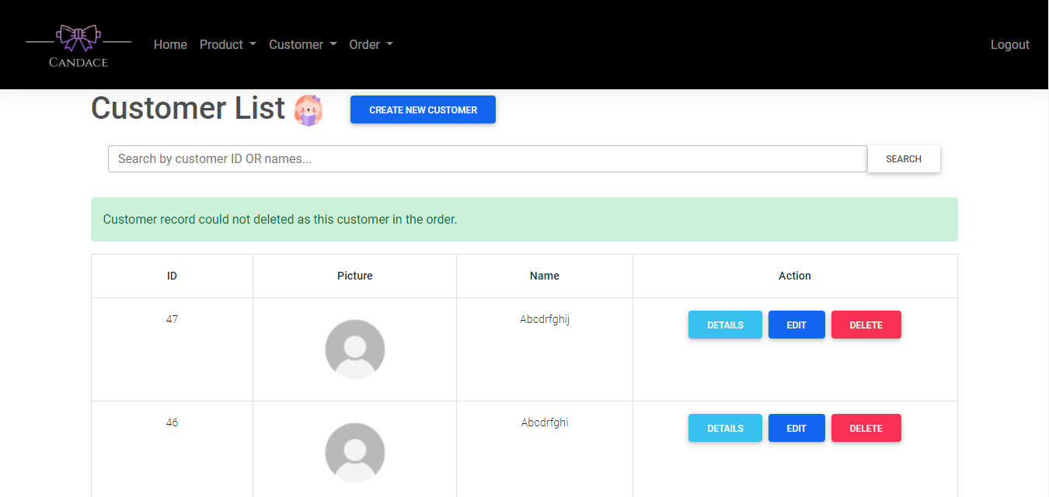

**(Figure 8.7 - Delete customer(eg:Carol560) which in order in Customer Edits Page)**

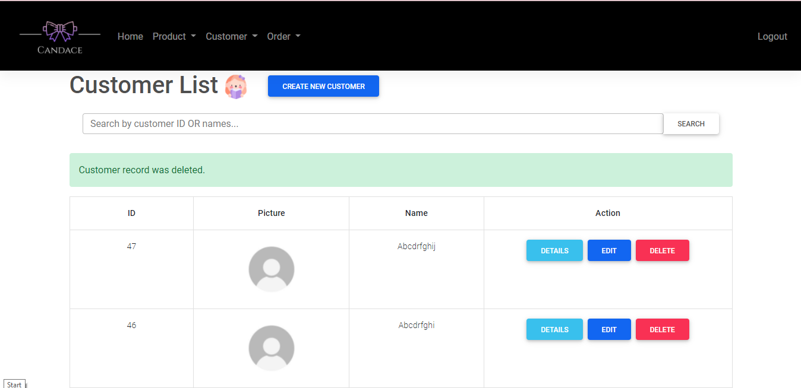

**(Figure 10.1 - Without filling all the field in Customer Edits Page)**

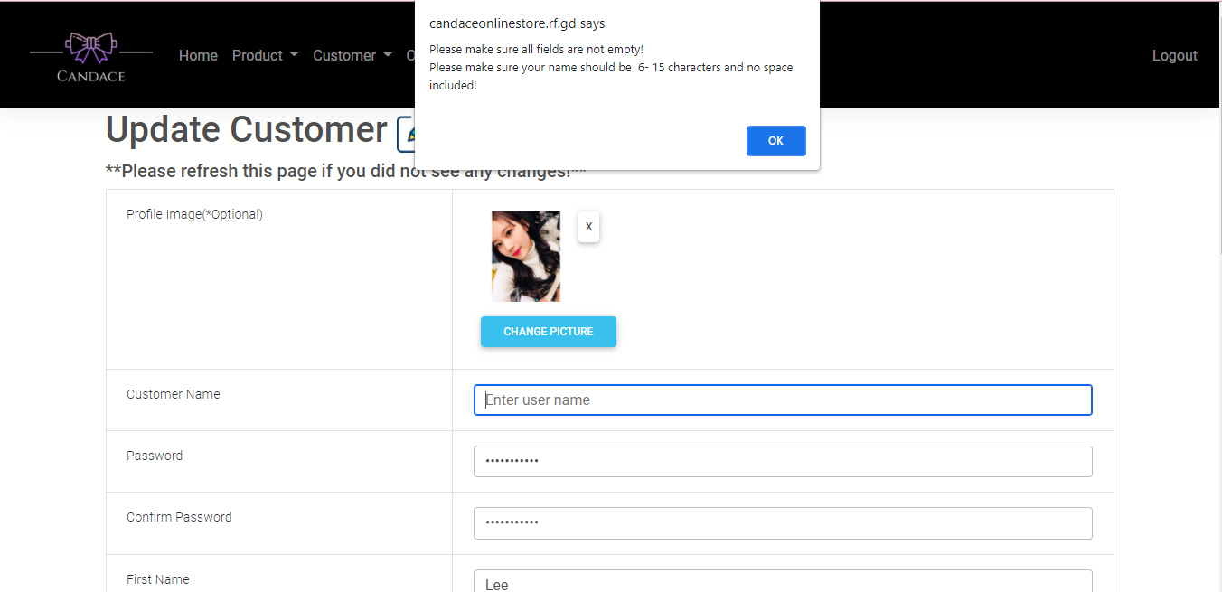

**(Figure 10.2 -Filling the username field which less than 6 character or more than 15 character in Customer Edits Page)**

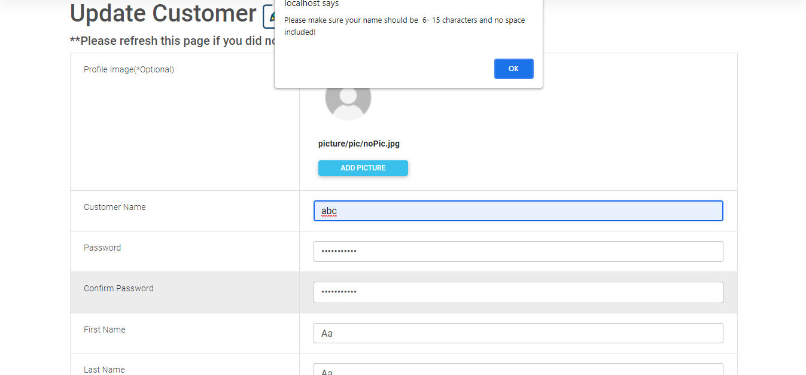

**(Figure 10.3 -Password field not same as confirm password field in Customer Edits Page)**

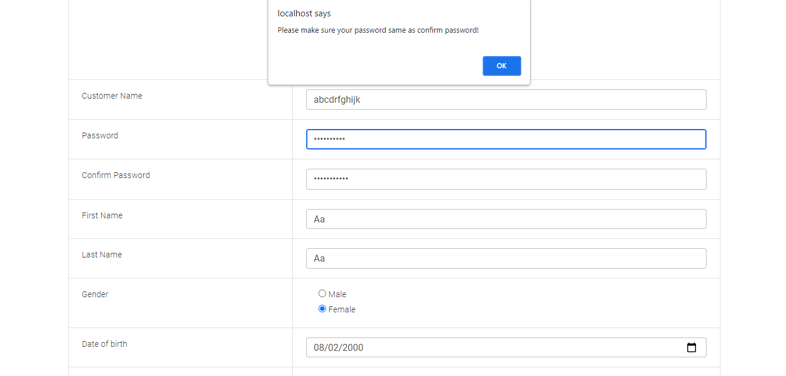

**(Figure 10.4 -Password field and confirm password field not contain at least one lowercase letter, one uppercase letter, one numeric digit in at least 8 characters in Customer Edits Page)**

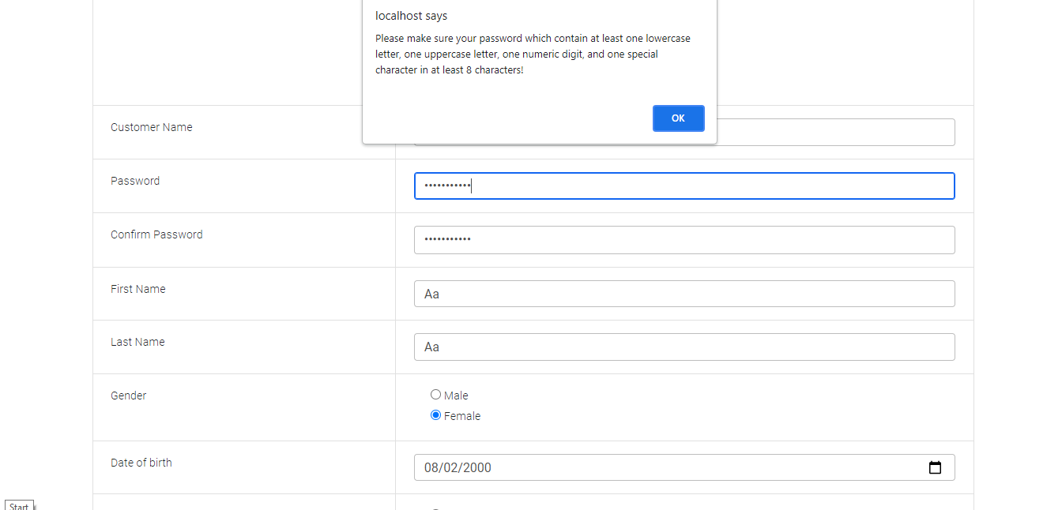

**(Figure 10.5 - Filling age lower than 18 years old in Customer Edits Page)**

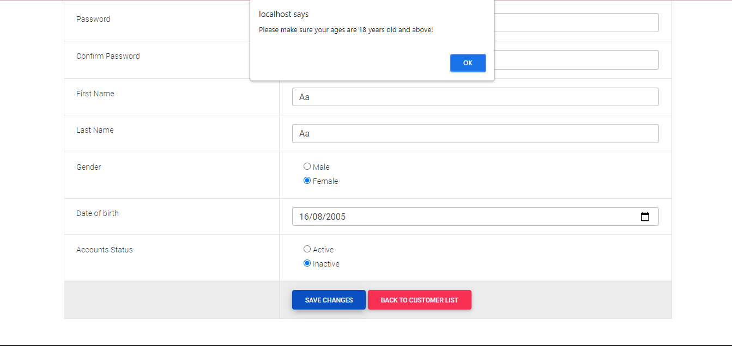

**(Figure 10.6 - Upload non-image file in product image in Customer Edits Page)**

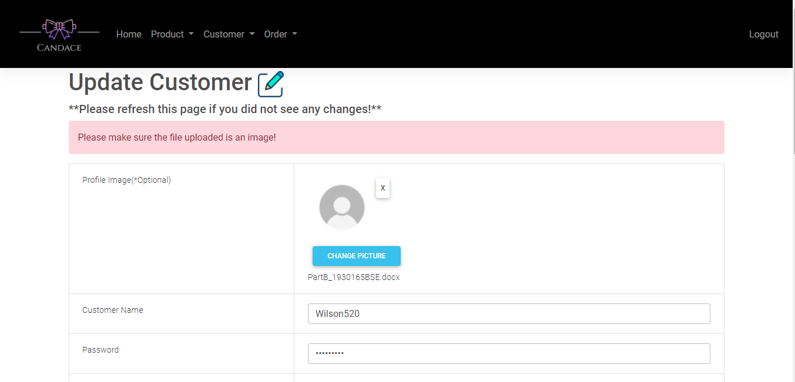

**(Figure 10.7 - Upload file in product image which its width and height is not the same in Customer Edits Page)**

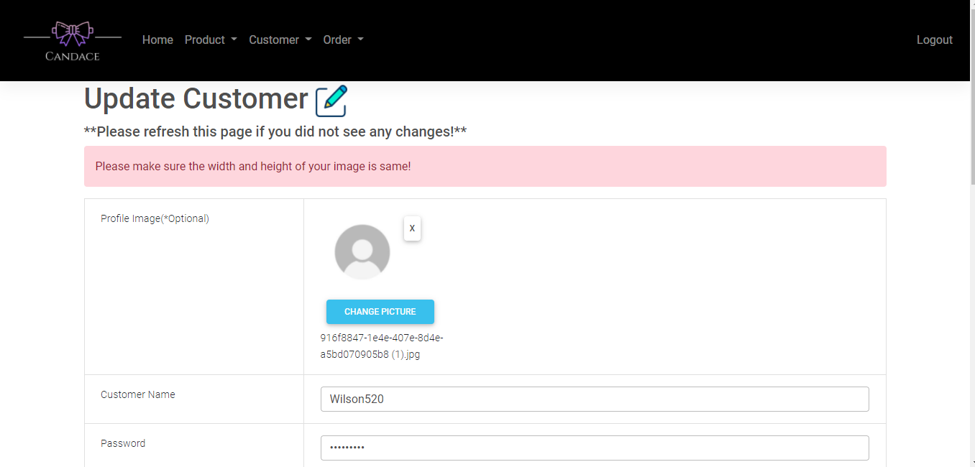

**(Figure 10.8 - Upload file in product image which its size larger than 512kb in Customer Edits Page)**

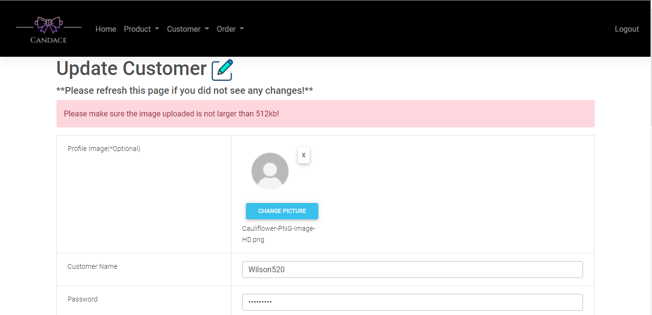

**(Figure 10.9 - Filling all the field without any error in Customer Edits Page)**

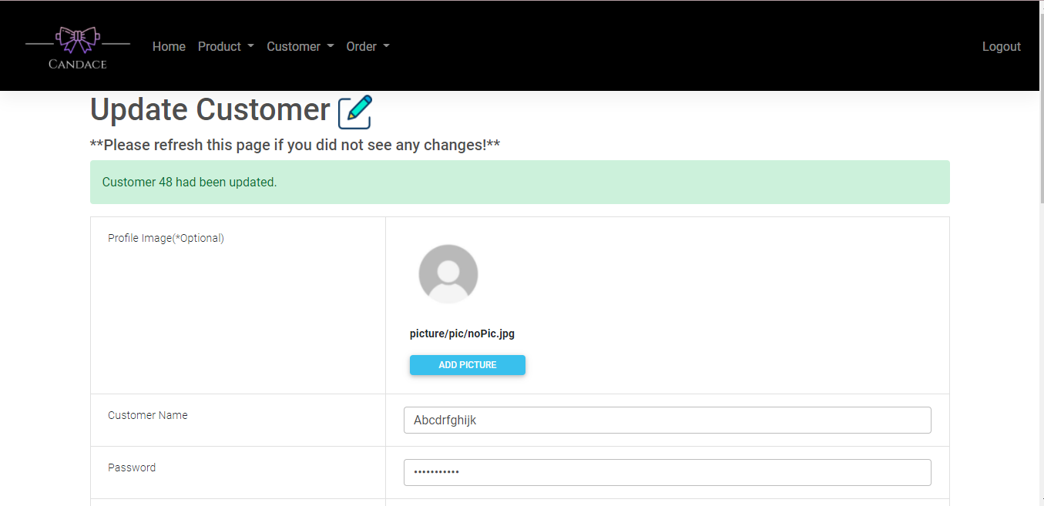

**(Figure 10.11 - Delete an existing profile image in Customer Edits Page)**

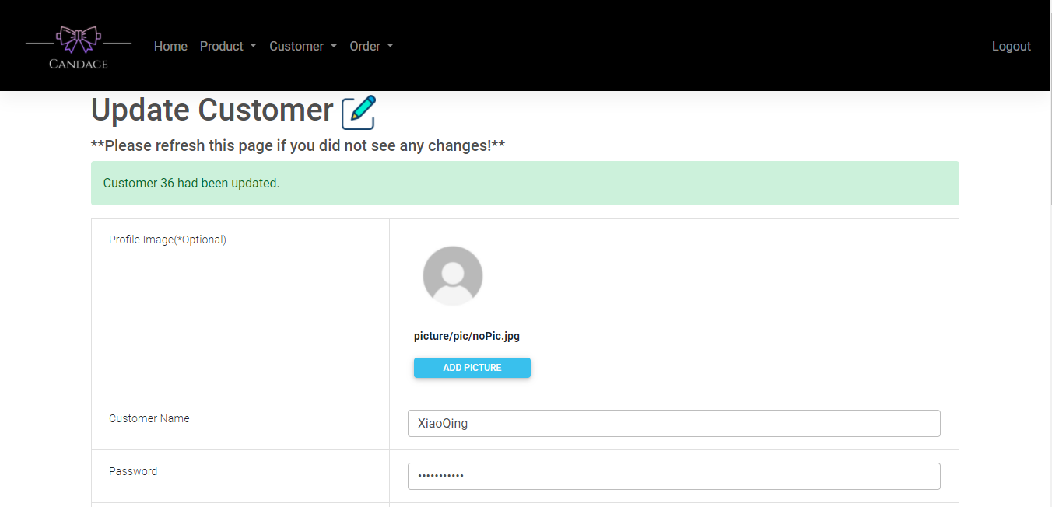

**(Figure 11.1 - Without fill in customer username in Create Order Page)**

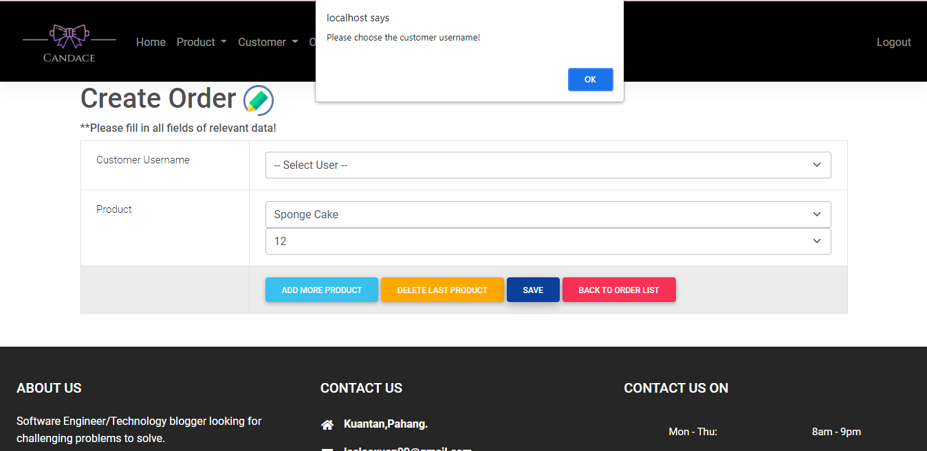

**(Figure 11.2 - Without fill in product name in Create Order Page)**

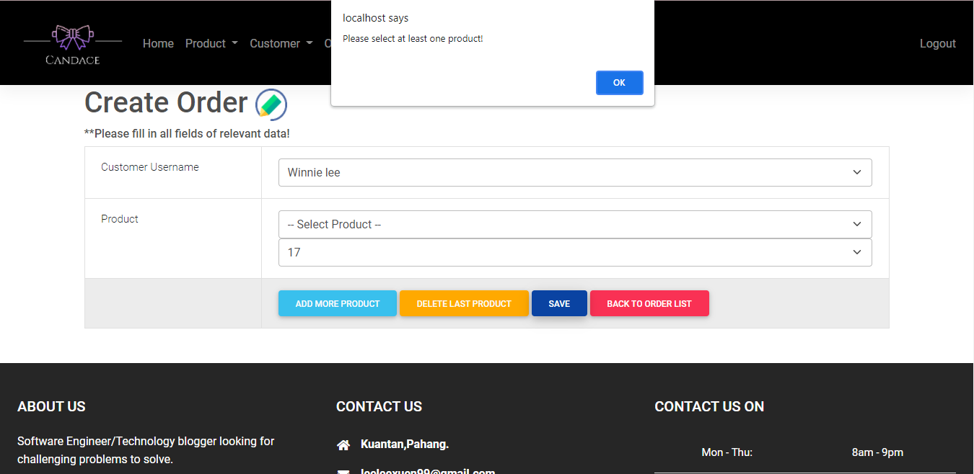

**(Figure 11.3 - Without fill in quantity of product in Create Order Page)**

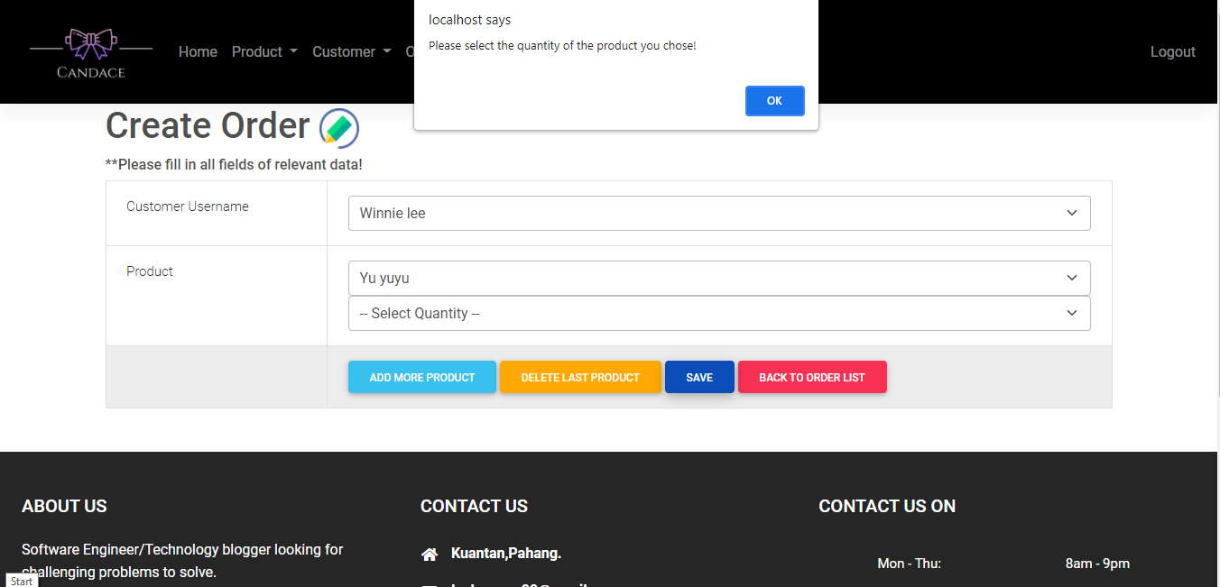

**(Figure 11.4 - ADD MORE PRODUCT in Create Order Page)**

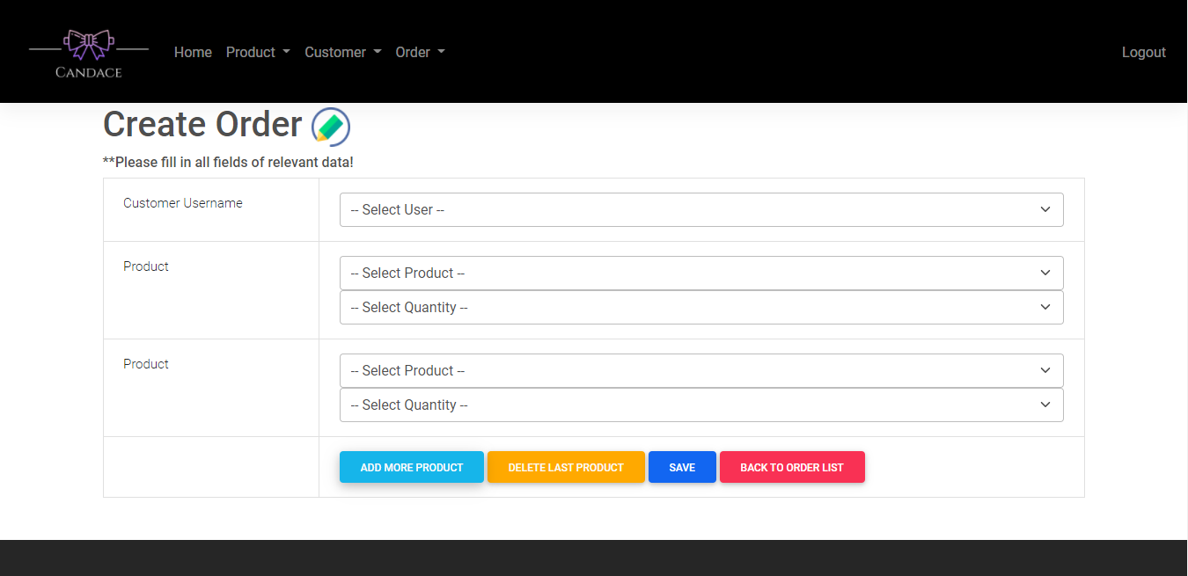

**(Figure 11.5 - DELETE LAST PRODUCT in Create Order Page)**

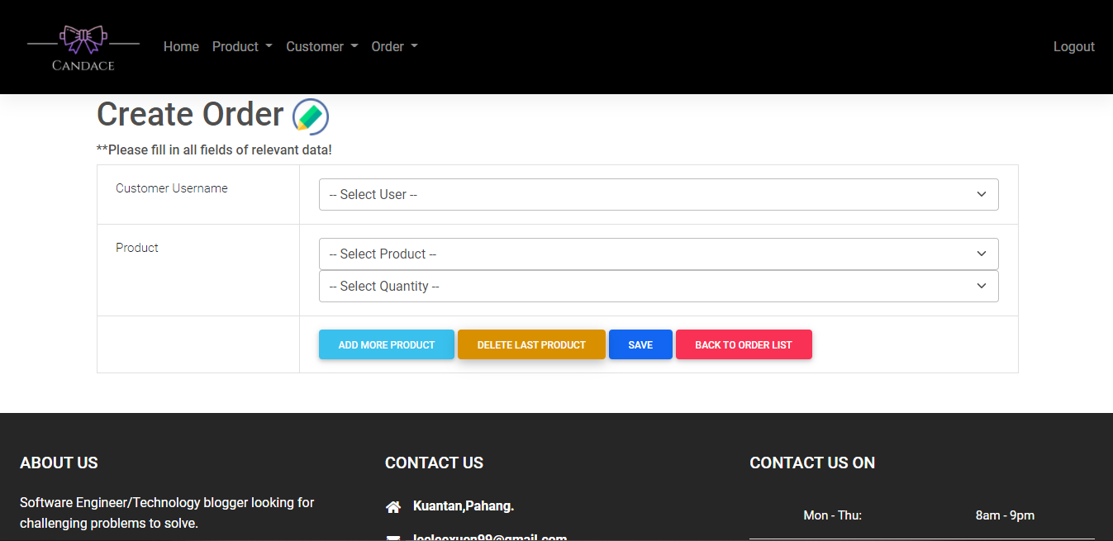

**(Figure 11.6 - Direct to Order List Page)**

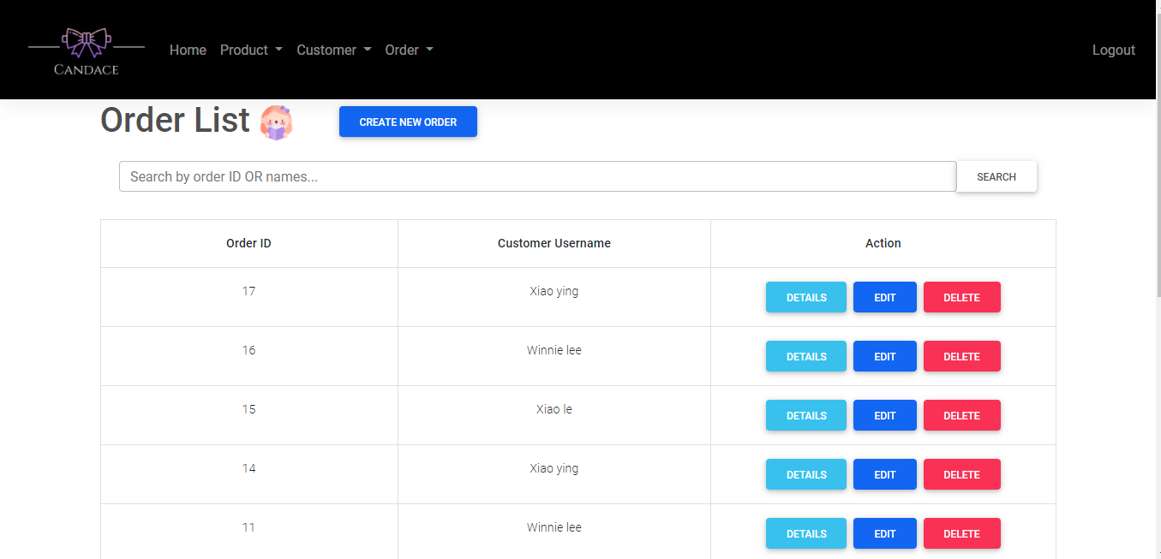

**(Figure 11.7 - Fill in all the fields in Create Order Page)**

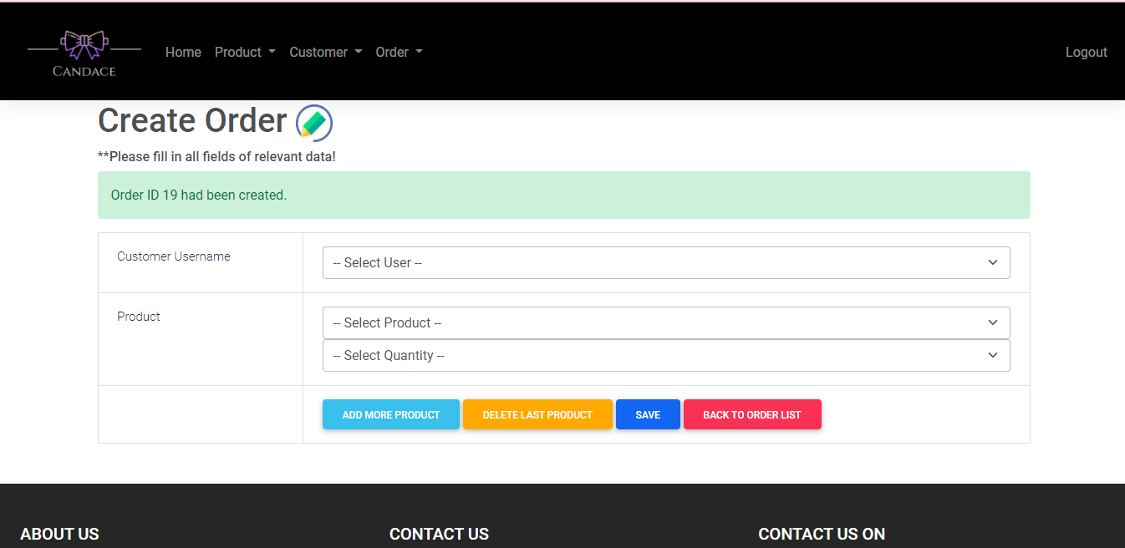

**(Figure 12.1 - Search the right id or name in Order List Page)**

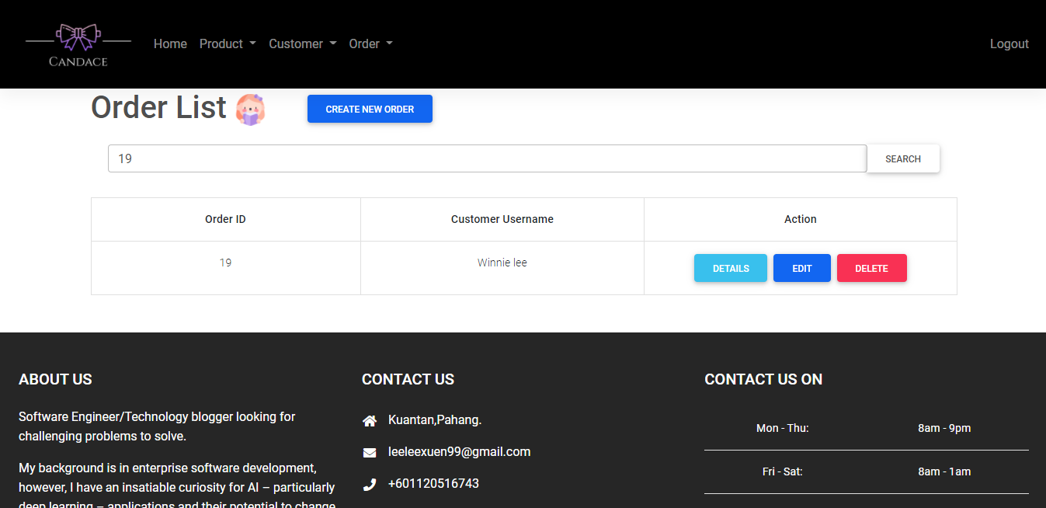

**(Figure 12.2 - Search the wrong id or name in Order List Page)**

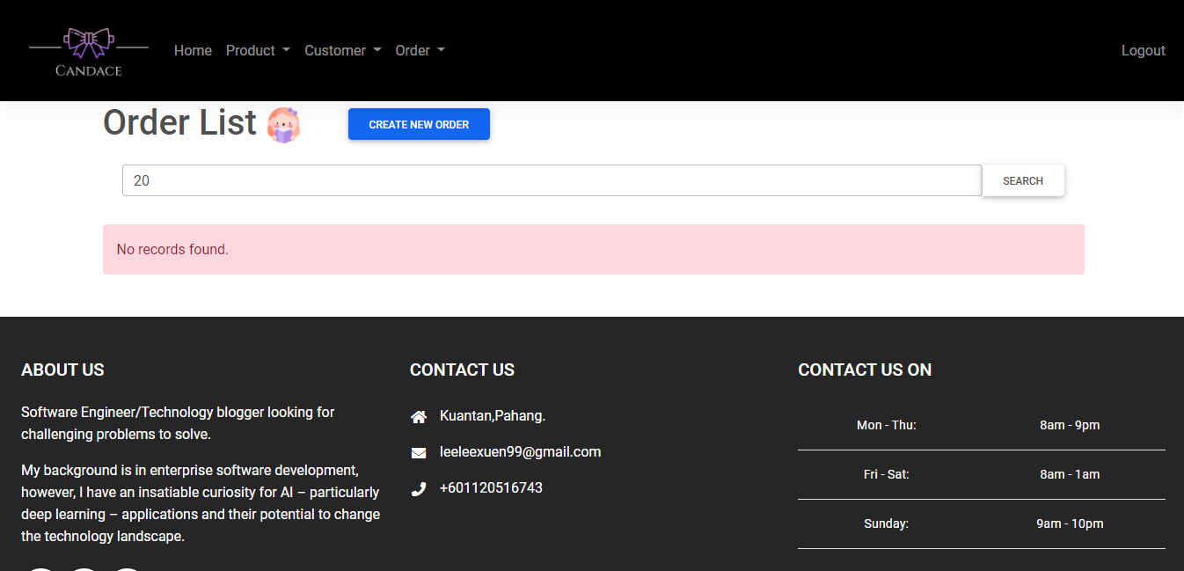

**(Figure 12.3 - Direct to Order Details Page)**

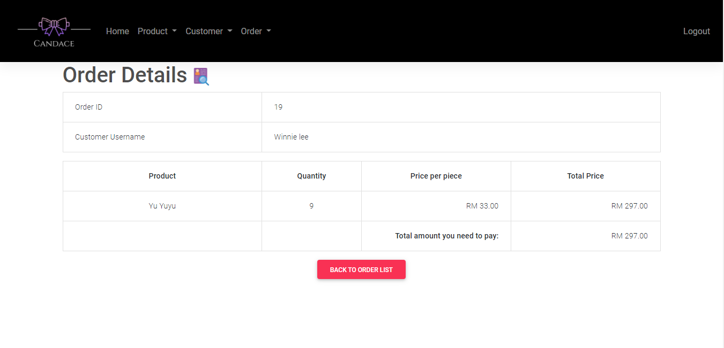

**(Figure 12.4 - Direct to Order Edits Page)**

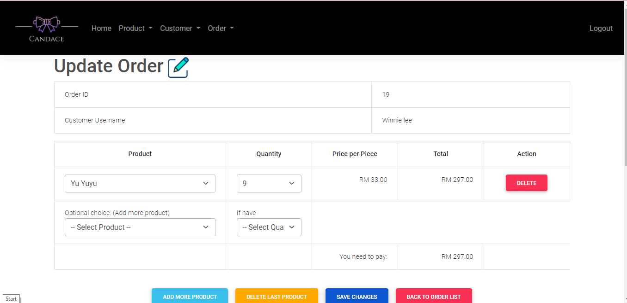

**(Figure 12.5 - Delete the order in Order List Page)**

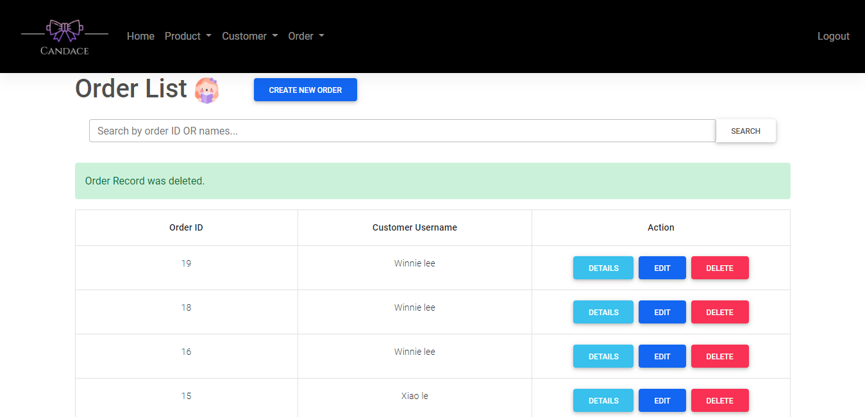

**(Figure 14.1 - Change product in Order Edits Page)**

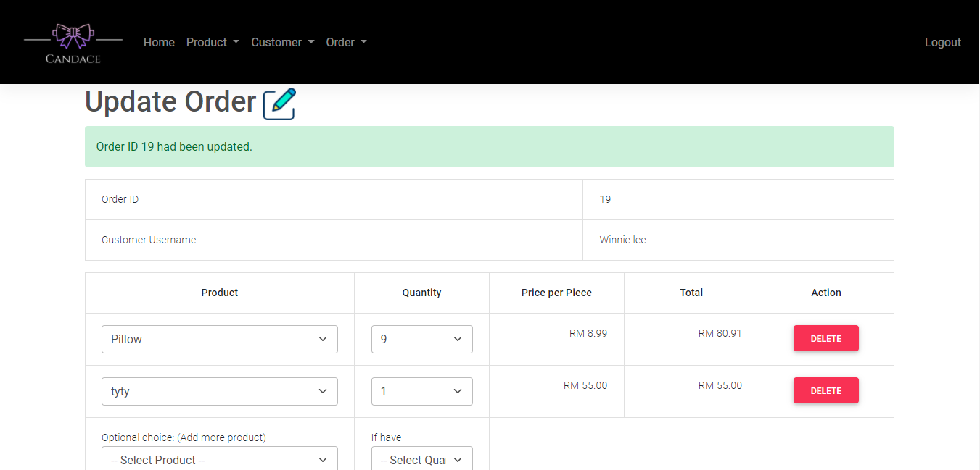

**(Figure 14.2- Change quantity of product in Order Edits Page)**

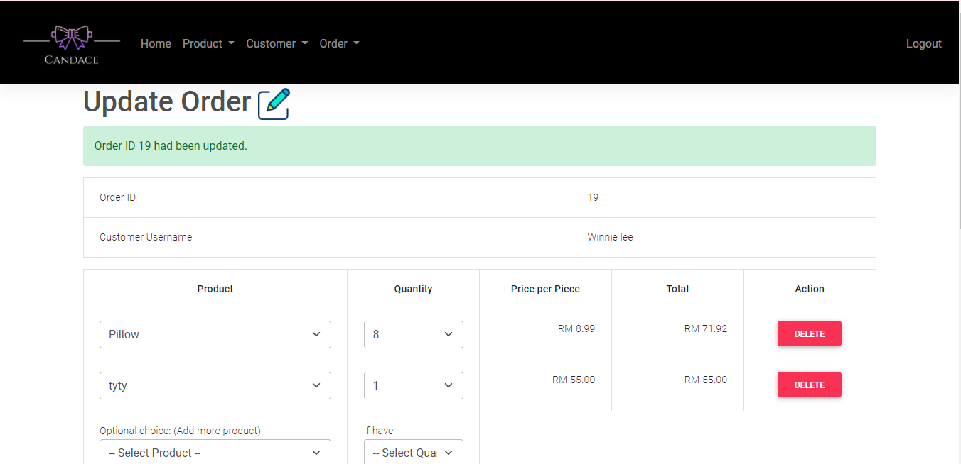

**(Figure 14.3- ADD MORE PRODUCT in Order Edits Page)**

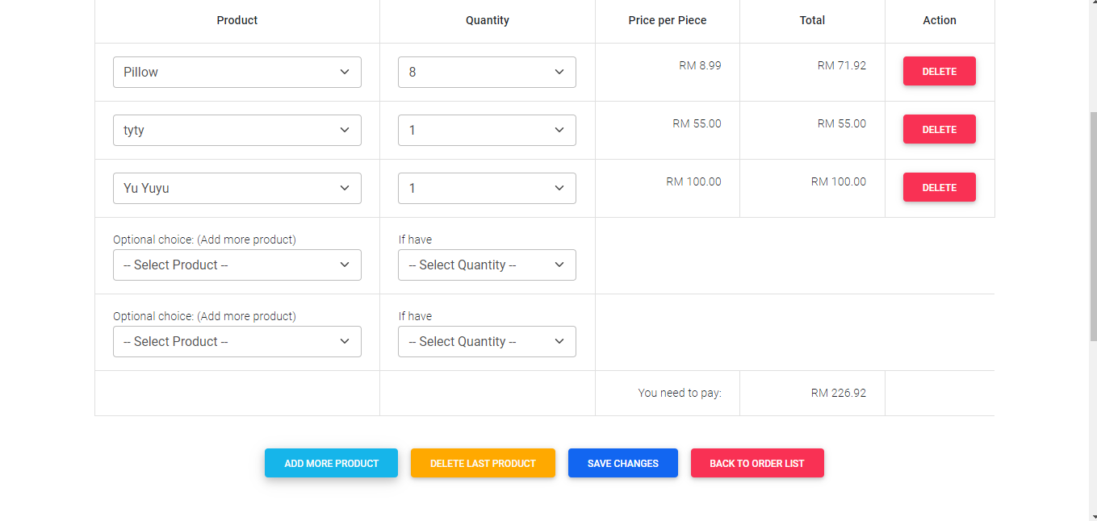

**(Figure 14.4 - DELETE LAST PRODUCT in Order Edits Page)**

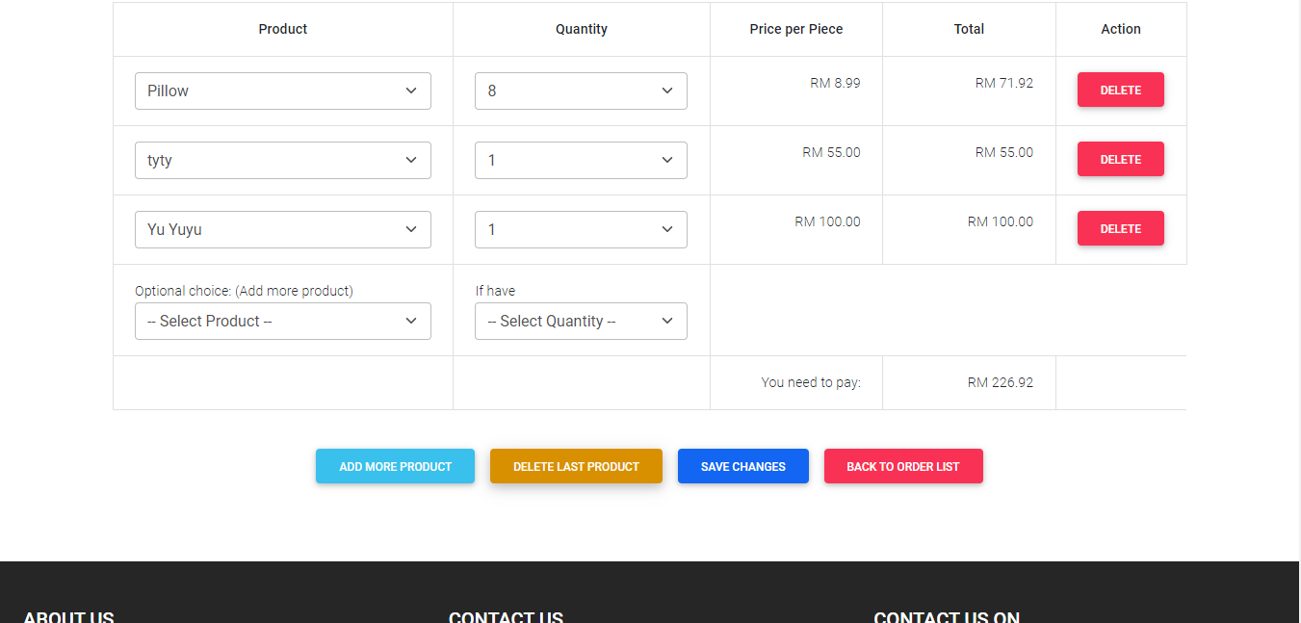

**(Figure 14.5 - Just choose quantity in Order Edits Page)**

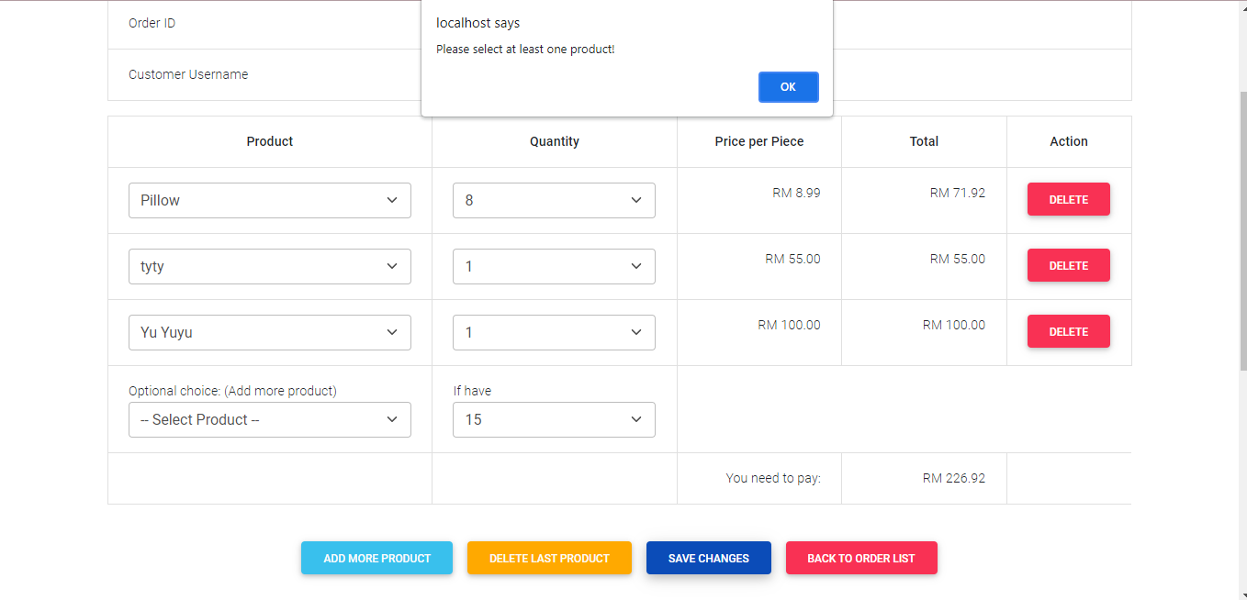

**(Figure 14.6 - Just choose product in Order Edits Page)**

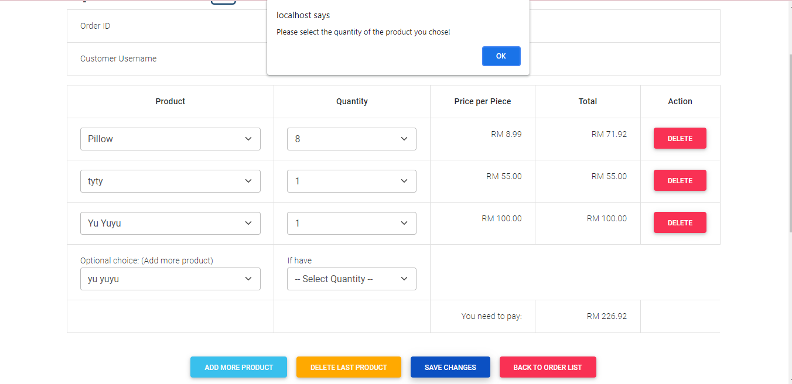

**(Figure 14.7 - Delete certain order which contain more than one order in Order Edits Page)**

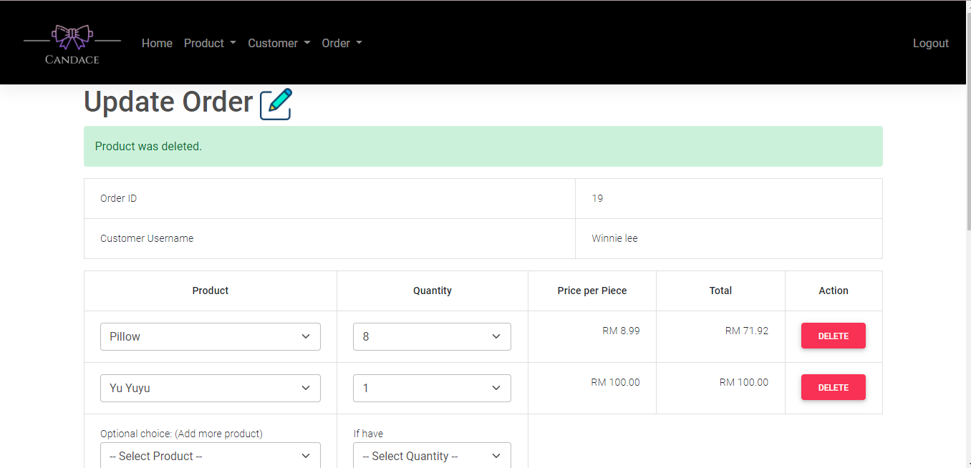

**(Figure 14.8 - Delete certain order which contain less than one order in Order Edits Page)**

